**TENSORFLOW: ADVANCED TECHNIQUES SPECIALIZATION**

Note: There are probably a lot of typos and spelling mistakes. I just wrote the notes while following the specialization and did not proof-read them afterwards.

Contenido

COURSE 1: CUSTOM MODELS, LAYERS AND LOSS FUNCTIONS WITH TENSOR FLOW 2

Week 1: Functional APIs 2

Week 2: Custom Loss Functions 3

Week 3: Custom layers 6

Week 4: Custom models 9

Week 5: Callbacks 13

COURSE 2: CUSTOM AND DISTRIBUTED TRAINING WITH TENSORFLOW 16

Week 1: Differentiation and Gradients 16

Week 2: Custom training 19

Week 3: Graph Mode 24

Week 4: Distributed Training 26

Course 3: ADVANCED COMPUTER VISION WITH TENSORFLOW 34

Week 1: Introduction to Computer Vision 34

Week 2: Object Detection 36

Week 3: Image Segmentation 40

Week 4: Visualization and Interpretability 43

COURSE 4: GENERATIVE DEEP LEARNING WITH TENSORFLOW 48

Week 1: Style Transfer 48

Week 2: Autoencoders 55

Week 3: Variational Autoencoders 58

Week 4: Generative Deep Learning with TensorFlow 62

# COURSE 1: CUSTOM MODELS, LAYERS AND LOSS FUNCTIONS WITH TENSOR FLOW

## Week 1: Functional APIs

1. Defining the input:  
   from tensorflow.keras.layers import Input

input = Input(shape=(28,28))

1. Defining the layers:  
   from tensorflow.keras.layers inport Dense, Flatten

x = Flatten()(input)

x = Dense(128, activation = ‘relu’)(x)

predictions = Dense(10, activation = ‘softmax’)(x)

1. Define the model using the input and output layers

from tensorflow.keras.models import Model

func_model = Model(inputs = input, outputs = prediction)

We can define multiple inputs or outputs as follows:

func_model = Model (inputs = [input1, input2], outputs = [output1, output2])

To concatenate multiple layers into one, we use the syntax:

merge = Concatenate([layer2_1, layer2_2, layer2_3])

## Week 2: Custom Loss Functions

Two ways to specify the loss function to use:

1. model.compile(loss = ‘mse’, optimizer = ‘sgd’)
2. from tensorflow.keras.losses import mean_squared_error  
   model.compile(loss = mean_squared_error, optimizer = ‘sgd’)

With the second way, we can specify parameters:

model.compile(loss = mean_squared_error(param = value), optimizer = ‘sgd’)

Create a custom loss function:

def my_loss_function(y_true, y_pred):

# Computation of loss by comparing y_true and y_pred

return losses

Example: Uber Loss Function

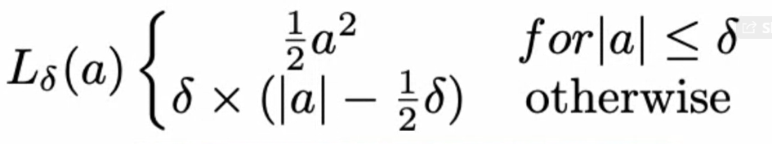

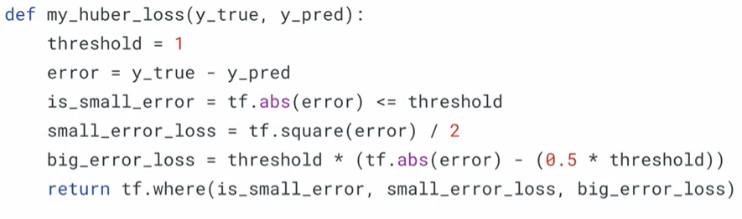

Then, we can call the huber loss by doing

model.compile(optimizer = ‘sgd’, loss = ‘my_huber_loss’)

To give parameters to the loss functions, we have to create a wrapper function:

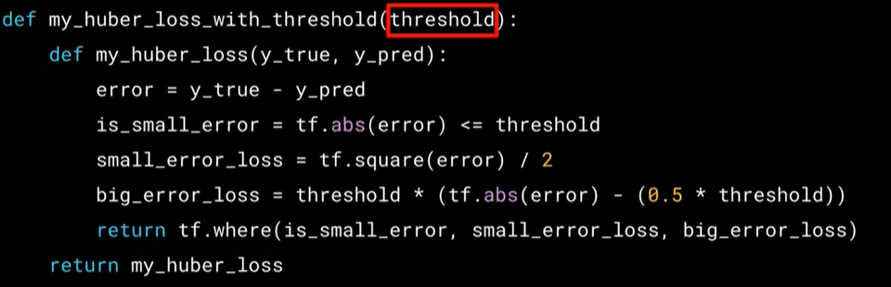

To use the function with the parameter, we call the wrapper function:

model.compile(optimizer = ‘sgd’, loss = my_huber_loss_with_threshold(threshold = 1))

This has to be done like this, because the loss function must only have as parameters y_true and y_pred.

We can also implement loss functions as a class:

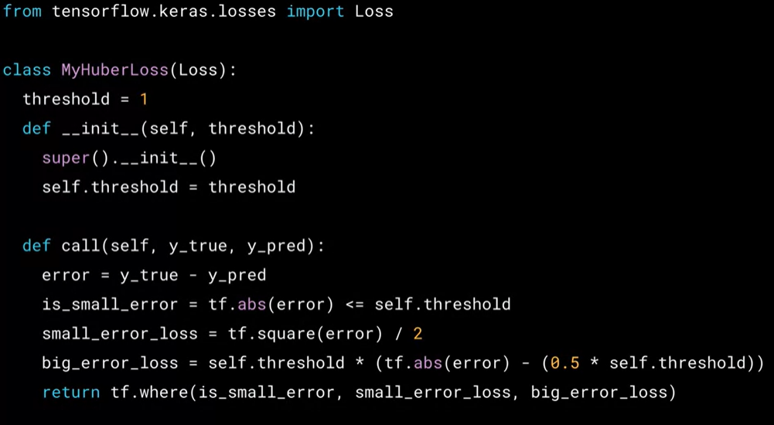

Then we can use that loss function y doing:

model.compile(optimizer = ‘sgd’, loss = MyHuberLoss(threshold=1))

Example: Contrastive Loss.



Used to compare two vectors and see if they are similar or not. Y is 1 if the vectors are similar and 0 if not. D is the tensor of Euclidean distances of both vectors. Margin is a constant we can use to enforce a minimum distance between the two vectors in order to consider them similar or not

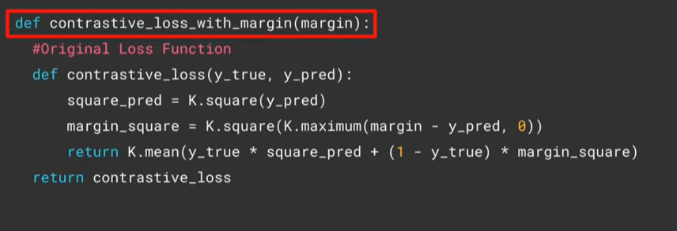

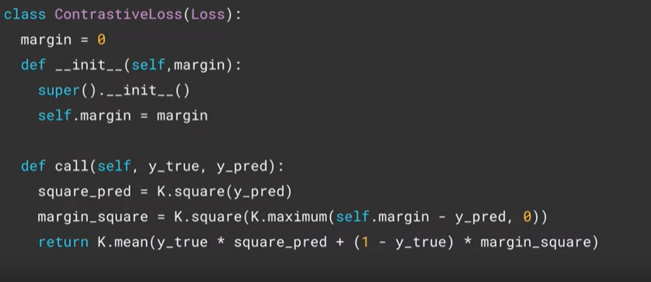

## Week 3: Custom layers

The purpose of a Lambda layer is to execute an arbitrary function within a sequential or functional API module. It is best suited for something simple or if we want to experiment.

Simple lambda layer:

tf.keras.layers.Lambda(lambda x: tf.abs(x))

A lambda layer can call a function:

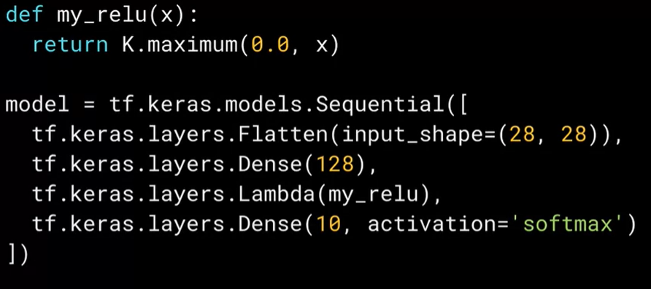

If we want to do something more advanced, like layers that are trainable, we can’t use lambda layers. In that case, we have to build a custom layer which is trainable and can perform complex functionality by inheriting from existing functionality.

Commonly used layers:

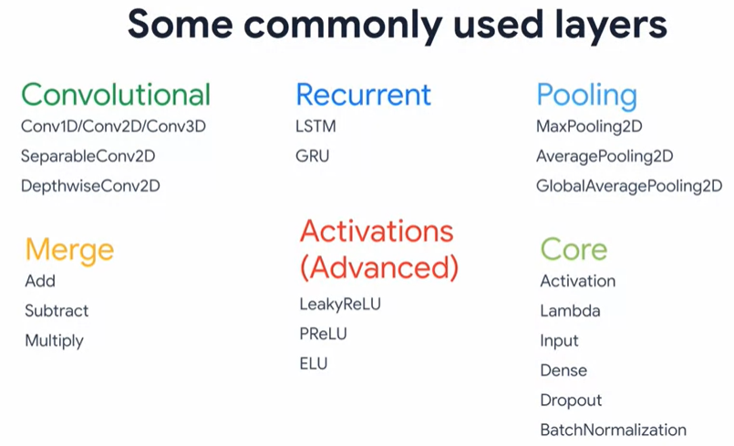

What is a layer? is a class that collects parameters that encapsulate state (weights) and computation (forward pass) to achieve the layer’s purpose in a neural network.

When we do model.fit(), the state (weights) of the layer is trained .

Example:

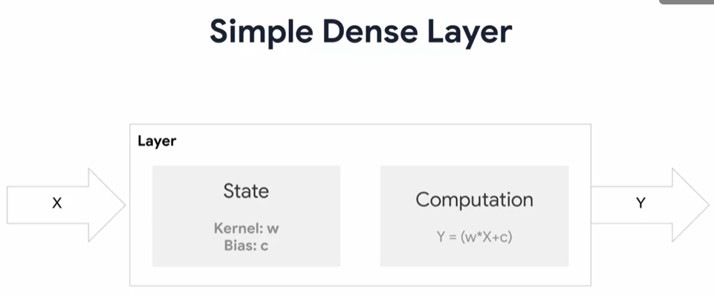

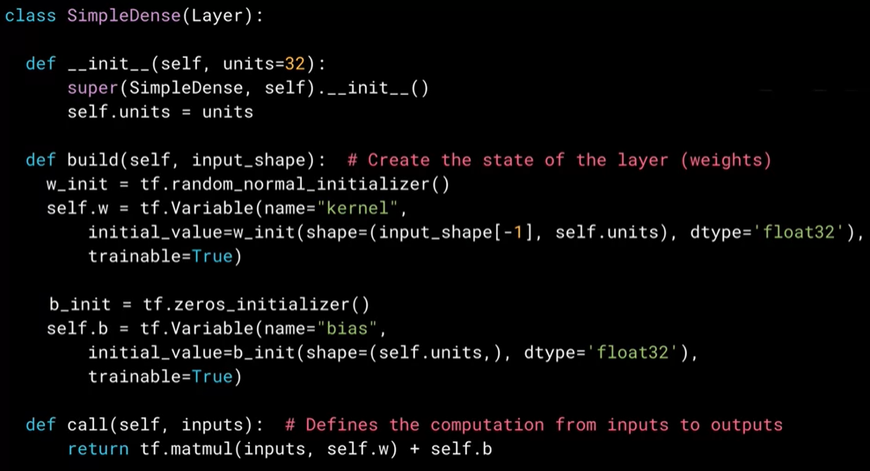

When defining a custom layer, we inherit from the Layer class by calling Layer in the definition of the class. Then, the class will need at least 3 methods:

1. __init__():  
   Initializes the class, accepts the parameters and sets up the internal variables.

The base class is Layer, so the first thing to do is to initialize that base class. This is done by calling super()

1. build():  
   Runs when the instance is created. Used to specify the local input states. Creates the state (weights) of the layer.

First we initialize the weights. In the example the weights are w and b. In Tensorflow we can initialize values randomly (normal distribution) using tf.random_normal_initializer() or initialize values to zero using tf.zeros.initializer().  
We set trainable = True to the weight (parameter) to tell tensorflow that the variable can be modified during training

1. call():  
   Performs the computation and is called during training to get the output from the cell.

To us the layer, we do:

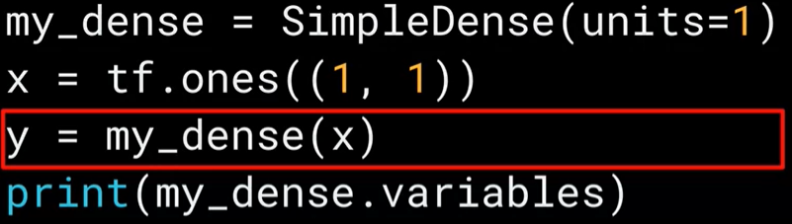

In a full network, it would be:

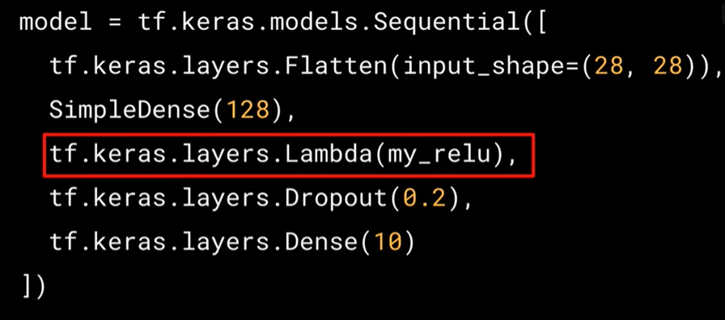

We can immediately add an activation function to the layer. To do so, we do not need to update the build method. We only need to edit the init and call functions.

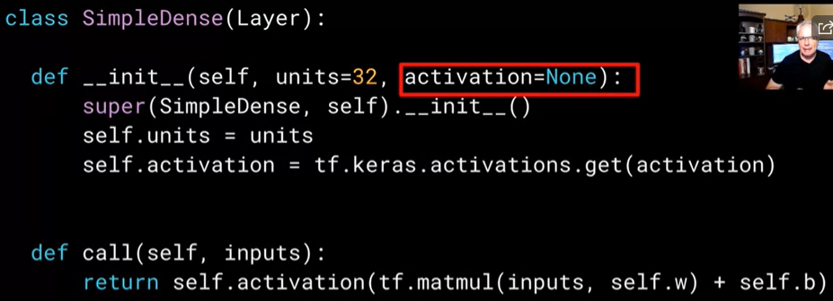

## Week 4: Custom models

Example network:

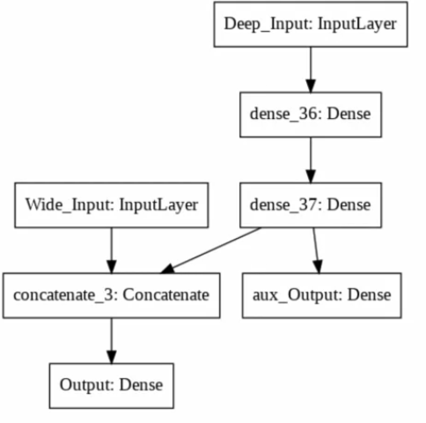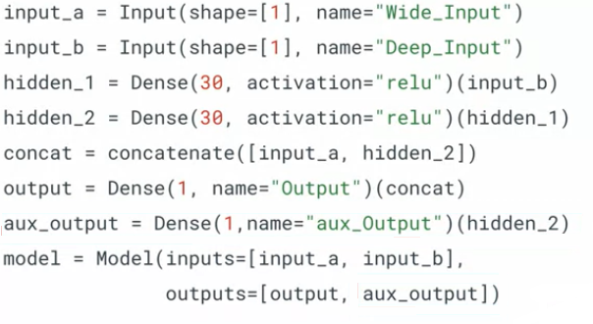

A network can be encapsulated into a class to tidy the code and easier reuse.

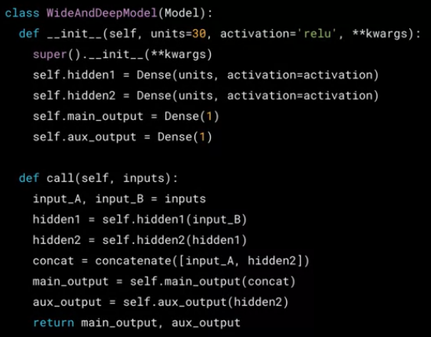

We create a class that calls the class Model.

We need to use the following two functions:

1. __init__():  
   Initializes the class and must also initialize the base class (Model). Then it creates the instances of the internal variables or states. The outputs and layers are defined here
2. call():

It is executed when the class is constructed. Here we define the model outputs which will be returned by the call function. The entire architecture is defined here. Here we can also define loops defining multiple layers, or if-else statements or other operations.

Then, we can create a model using an instance of the class:

model = WideAndDeepModel()

Since we use the parent class Model, we can also use the following methods when we encapsulate a model:

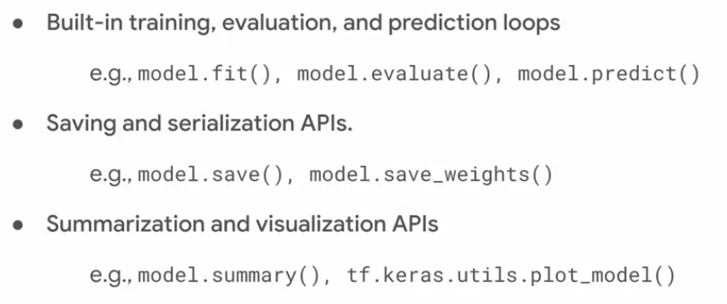

Benefits of subclassing models:

* Extends how we have been building models
* Continue to use sequential or functional API
* Modular architecture
* Try out experiments quickly
* Control flow in the network (we can have branches and loops)

Example of complex network (ResNet)

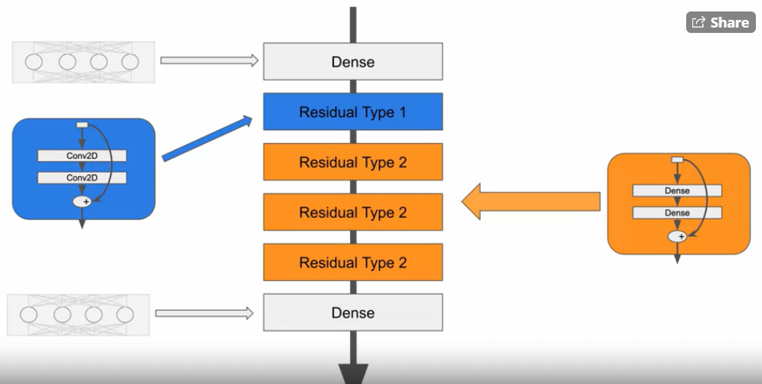

Which can be also built like this (where all the Residual Type 2 modules have the same weights)

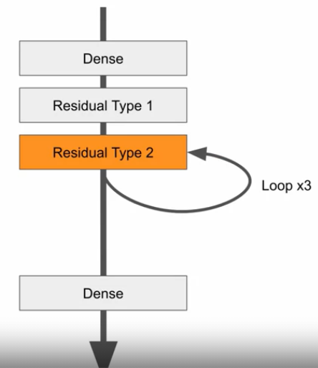

First we build the Convolutional Residual Block

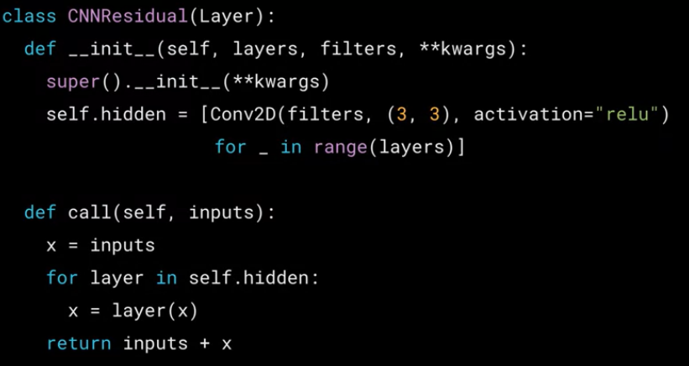

There we define the number of layers we want to implement with the parameter layers and the number of convolutional filters we want to use with the parameter filters. The part self.hidden defines the hidden layers to be Conv2D layers with the specified number of filters.  
Then, in the call function we flow data through the layers using a loop.

The DNN residual blocks are built similarly:

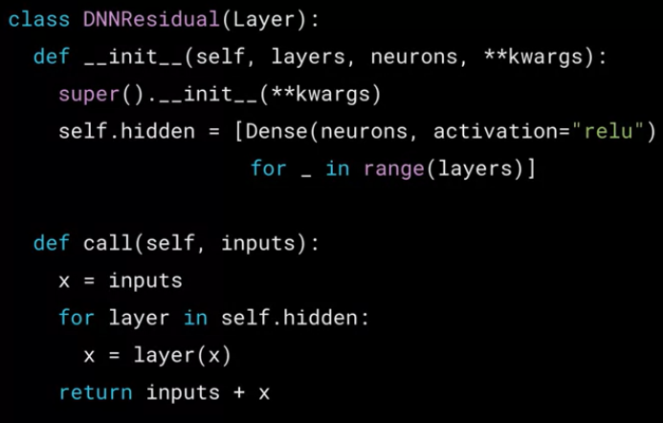

With these two modules, we can build the complete network:

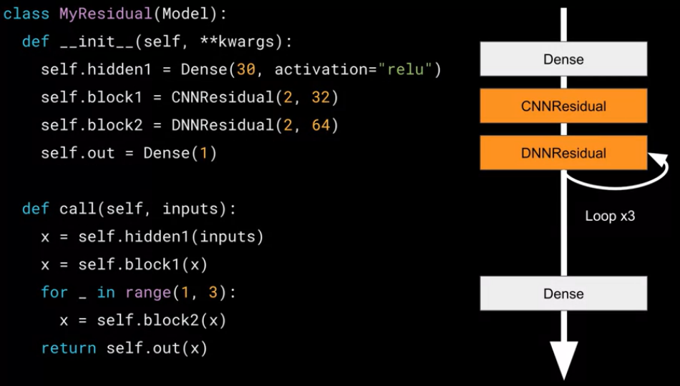

## Week 5: Callbacks

Callbacks are a functionality that lets us have control over the training process. There are pre-built callbacks and custom callbacks.

* Built-in callbacks

Subclasses of tf.keras.callbacks.Callback   
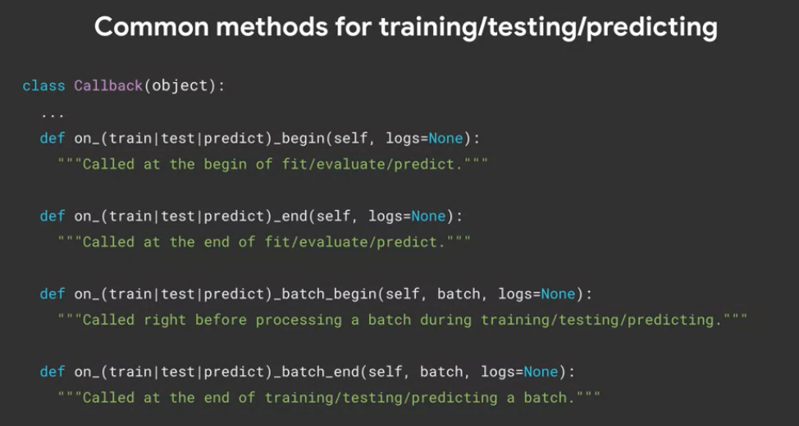

Where can we use them?

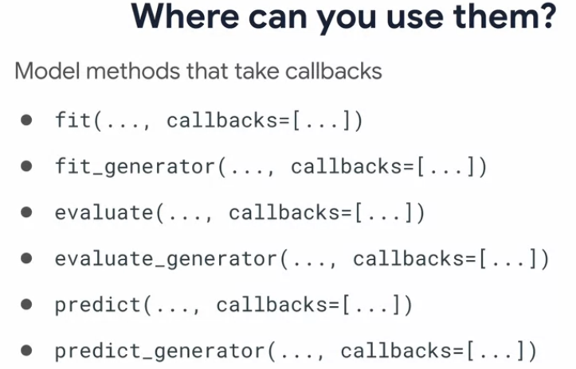

fit() and fit_generator(): Trains the model for a fixed number of epochs (iterations over a dataset, or data yielded batch-by-batch by a Python generator).

evaluate() and evaluate_generator(): Evaluates the model for given data or generator. Outputs the loss and metric values from the evaluation.

predict() and predict_generator(): Generates output predictions for the input data or data generator.

TensorBoard callback

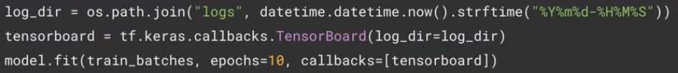

Then we load the extension by calling %load_ext tensorboard

And then we run tensorboard by calling %tensorboard –logdir logs

ModelCheckpoint: the model’s details can be saved epoch by epoch for later inspection or to monitor progress through them. We can choose to save only the best checkpoints/weights.

Saving the model epoch by epoch in the file model.h5:



Saving only the weights epoch by epoch in the file model.h5:



Saving only when we reach optimal values in the file model.h5:

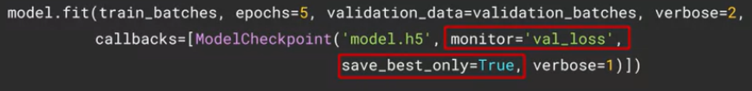

EarlyStopping checkpoint: to stop training when we achieve a metric that we want. Stops training when there is no improvement observed.

Preventing the model from overfitting by monitoring validation loss (monitor argument). Setting patience to 3 means that once we hit the best value, we log that and wait for 3 epochs to see if the values improve.

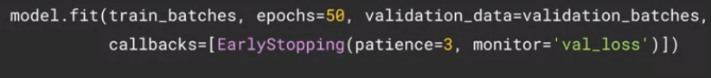

Restoring best weights if we don’t want to lose the weight values on the best epoch. To do that, we set restore_best_weights to True.

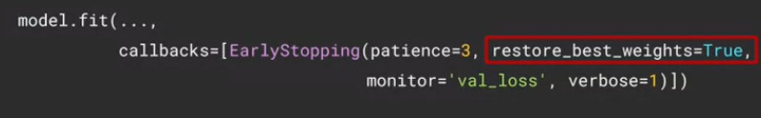

There are other parameters that we can play with. The ‘mode’ one is crucial to ensure that we are monitoring the values correctly. For some metrics we want to minimize, so we set ‘mode’ to ‘min’, while there are other metrics that we want to maximize, so we would set ‘mode’ to ‘max’

CSVLogger is another callback that is used to log training results in a csv file



Multiple callbacks can be called:

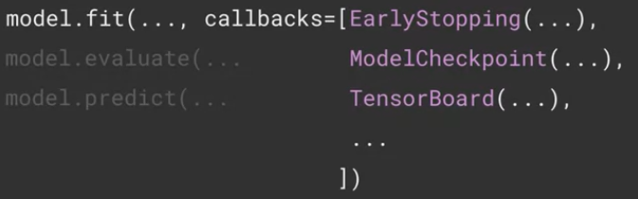

* Custom callbacks

General structure of a custom callback:

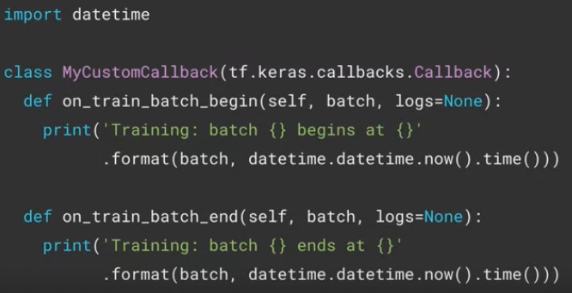

This previous example is a simple callback that prints the timestamp each time the training batch starts and ends. To use the callback we instantiate it and then call it in the .fit() function:

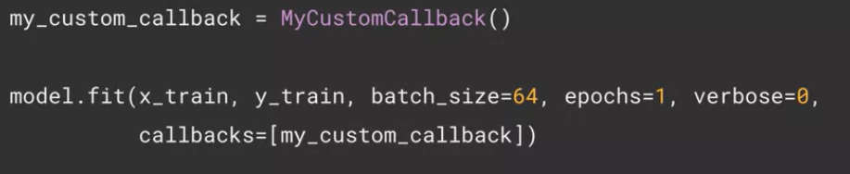

Another example: callback that checks the ratio of validation loss and training loss and if it is larger than certain threshold, the training is stopped:

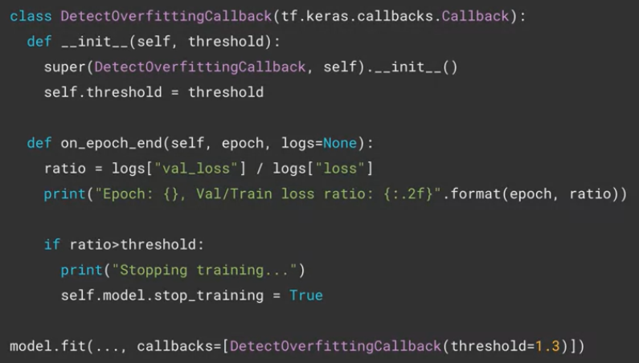

# COURSE 2: CUSTOM AND DISTRIBUTED TRAINING WITH TENSORFLOW

## Week 1: Differentiation and Gradients

Scalar: tensor of 0 dimensions

Vector: tensor of 1 dimension

Matrix: tensor of 2 dimensions

When coding in TensorFlow we create a tensor object. The easiest way is to do tf.Variable or tf.Constant

* Variable (mutable): tf.Variable(“Hello”, tf.string)
* Constant (inmutable): tf.constant([1,2,3,4,5,6])

The objects that manage the tensor datatype (Tensor) have 2 properties: Shape and Data type.

When creating a Tensor objects, we must specify how many units are needed for each dimension of the tensor (for example if we say shape = (2,), we are saying that the tensor has 1 dimension with 2 units in that dimension).

Example: tf.Tensor([4, 6], shape(2,), dtype=int32)

Example: tf.Variable([[1,2],[3,4]]). This creates a 2x2 variable

If we set shape = tf.TensorShape(None), the tensor is initialized with shape ‘unknown’, which means that the variable can be updated with an array of any other shape.

For complex numbers, use j instead of i and use dtype = tf.complex64

An important feature of tf.constant that differs from tf.Variable is that we can use tf.constant to reshape a 1D input variable using the shape parameter:

tf.constant([1,2,3,4,5,6], shape = (2,3)) is ok and creates the 2x3 matrix

tf.Variable([1,2,3,4,5,6], shape(2,3)) is not ok. Fails

Operations:

tf.add (can use + instead), tf.subtract (can use – instead), tf.multiply (can use * instead), tf.square, tf.reduce_sum (adds all the values of the tensor)

Tensors from tf are compatible with numpy operators. There is also interoperability.

In Tensorflow, optimizers are implemented using TensorFlow automatic differentiation API called Gradient Tape. This API lets us compute and track the gradient of every differentiable tensorflow operation.

To use Gradient Tape:

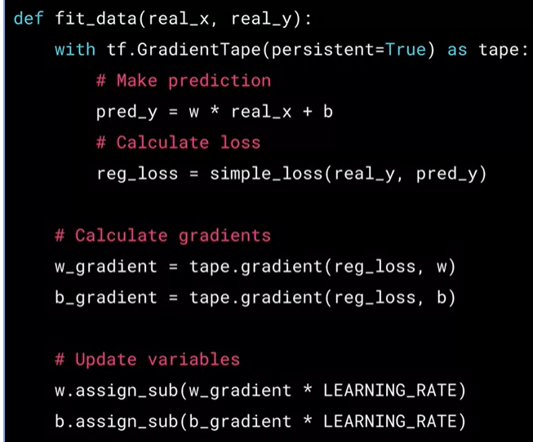

tape.gradient(reg_loss, w) differentiates the loss value with respect to w..

To perform a training step of a learning algorithm using the Gradient Tape API, we need to complete 2 crucial stages of the learning algorithm inside the context of the Gradient Tape:

1. Forward pass of the model
2. Loss obtained at each forward pass

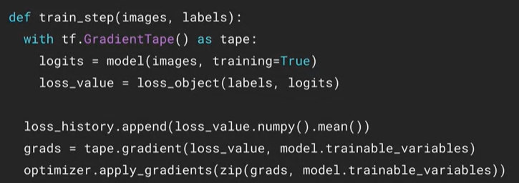

How to use GradientTape to calculate the gradient of a single equation:

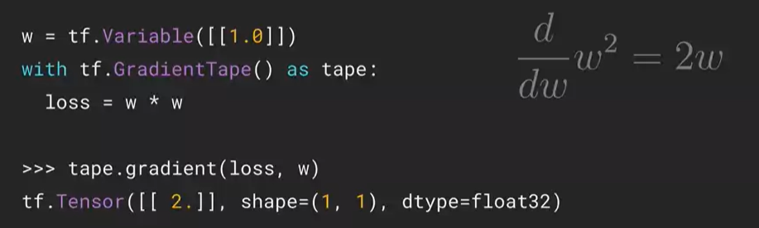

Operations within a gradient tape scope are recorded if at least one of their variables is watched. This is done with the command tape.watch(x):

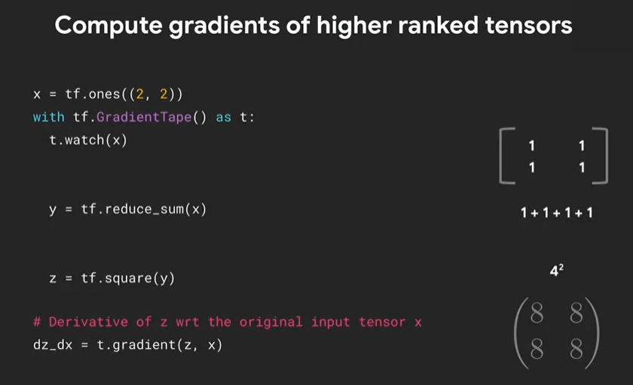

When we use a Gradient Tape, the resources held by it are released as soon as the gradient method is called. If we want to use them again, we can set the gradient tape to be persistent by setting persistent to True in

with tf.GradientTape(persistent = True) as t:

If we do that, we can call the gradient twice, for example:

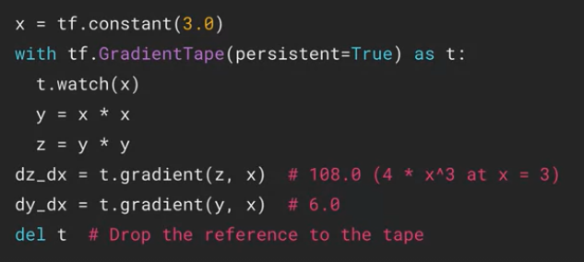

If we set persistent to True, we then need to dispose the tape doing del t.

We can take higher-order derivatives:

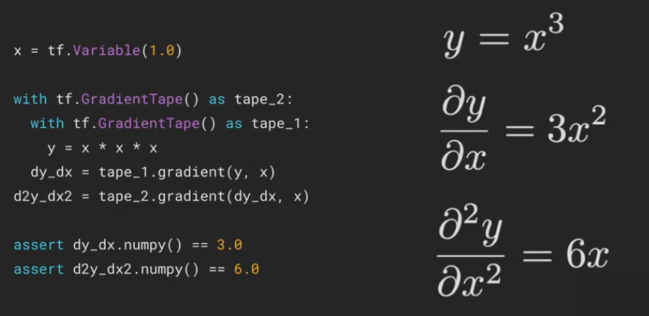

## Week 2: Custom training

Train a model using model.compile() and model.fit().

Specify optimizer, loss, etc. in model.compile().

Model.fit() loops through batches of training data to update trainable weights to minimize loss

Steps to train a network:

1. Define the network

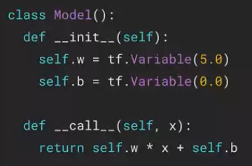

1. Prepare the training data

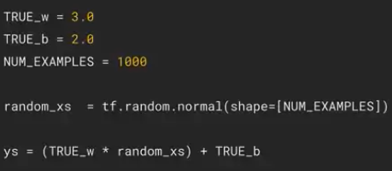

1. Define loss and optimizer

For this example we will use Mean Squared Error Loss: MSE = mean((Ytrue-Ypred)^2)

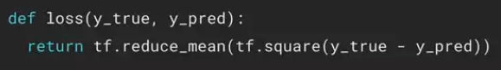

1. Train the model on training inputs by minimizing loss using the optimizer

Calculate the gradient of the loss function and move in direction of negative of gradient. The size of the step will be –gradient*learning rate.

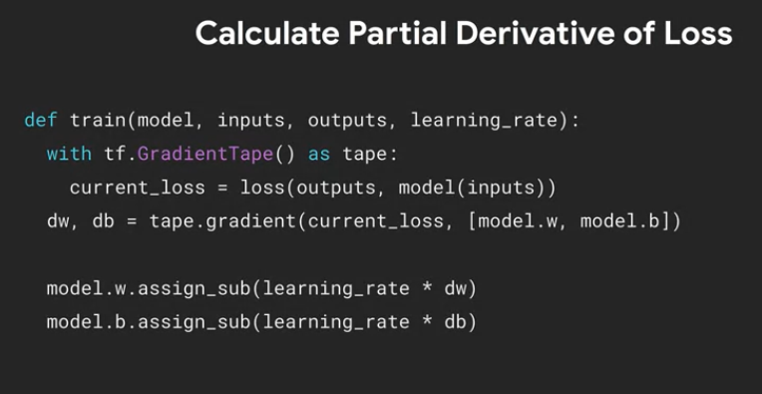

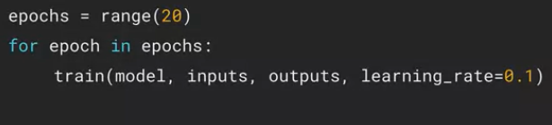

1. Validate the model

Example (clothes image classification using fashion mnist)

1. Define network  
   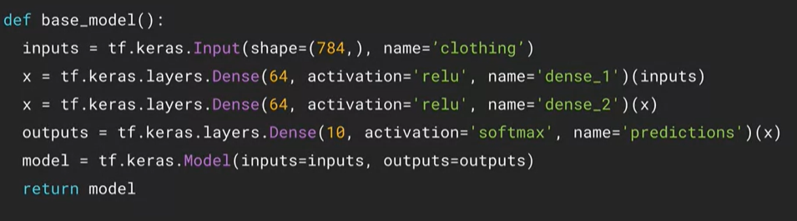
2. Prepare training data  
   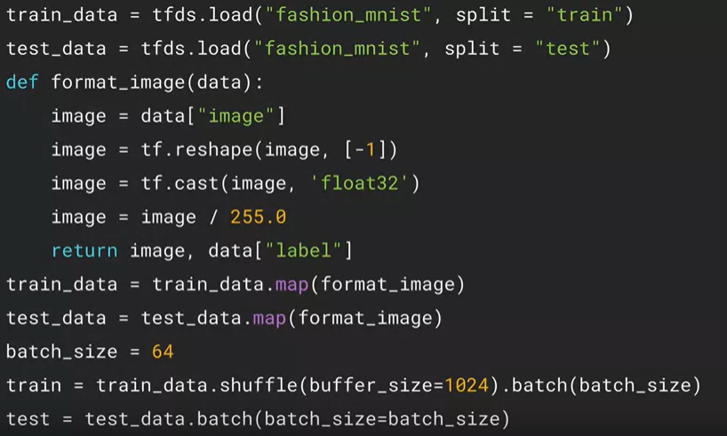
3. Define loss and optimizer  
   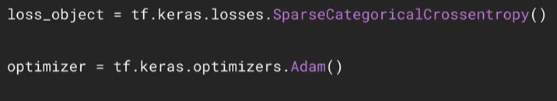

We use SparseCategoricalCrossentropy and not CategoricalCrossentropy when the category labels are integers and not already one hot encoded.

1. Define training loop  
   For each epoch, loop through the training batches and calculate gradients.  
   These gradients are used according to the optimization algorithm chosen to update the trainable parameters of the model.  
   Loop through validation batches and calculate validation loss

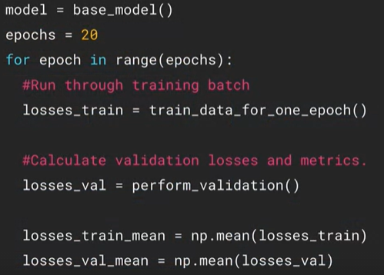

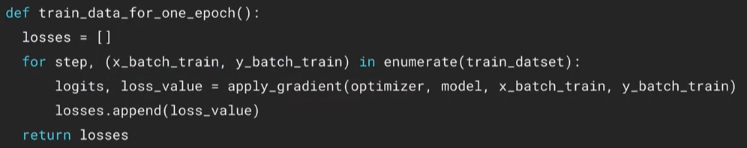

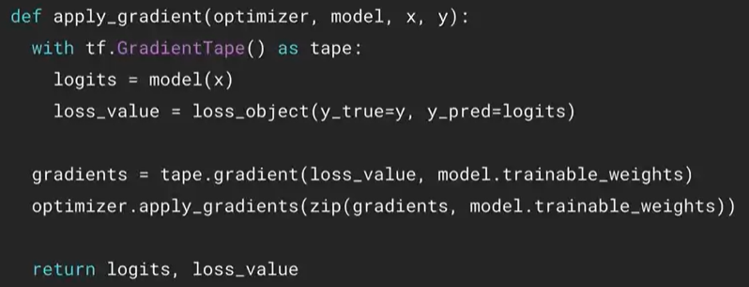

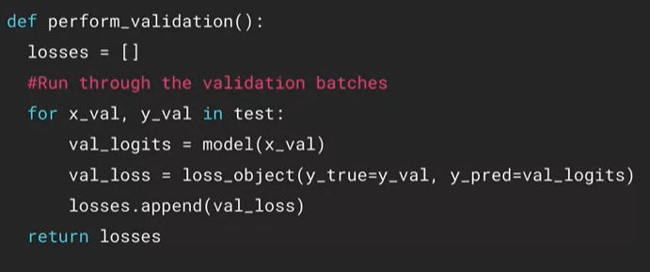

Metrics in Keras:

Metrics can be modelled as function or class. They are defined in tf.keras.metrics. When using metrics there are 3 main functions we would want to consider:

* metric.update_state() to accumulate metric statistics after each batch. To update the state of the metric. Typically done after each batch
* metric.result to get the current value of the metric for display
* metric.reset_state() to reset metric value typically at end of epoch

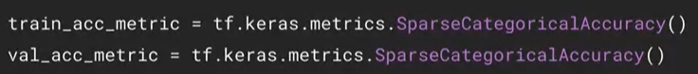

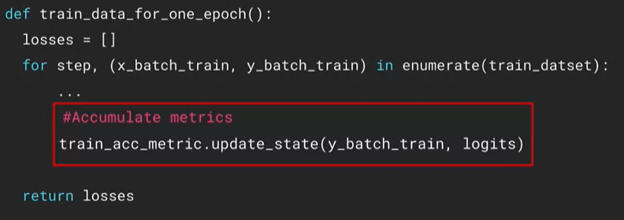

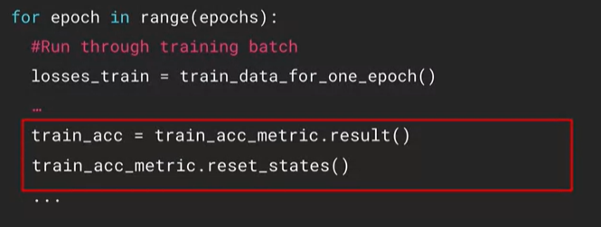

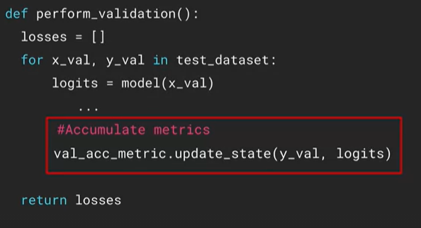

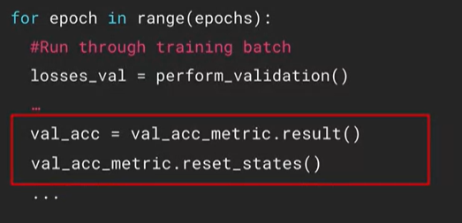

1. Validate the model  
   Show training process, calculate loss and accuracy for each epoch

Draw plots for loss function

Visualize performance on test data

## Week 3: Graph Mode

We have been using the eager mode of tensorflow. This mode allows to define everything and execute at the same time. However, there is another mode that is a little bit more efficient: graph mode.

Tensorflow was originally designed around programming to be done in graph mode, where we have to define a graph with all the operations before we execute them:

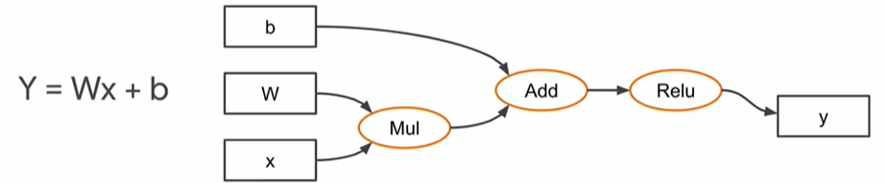

Using graphs can definitely speed up training and evaluation times, but are difficult to code. Specifically, the Mul, Add and Relu operations in the above graph don’t take place until the graph is fully designed, so they are difficult to debug.

Differences of eager and graph mode:

* Eager mode: intuitive interface, easier debugging, natural control flow:  
  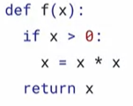
* Graph mode: parallelism, distributed execution, compilation, portability. They don’t support if conditionals, so we must use tf.cond()

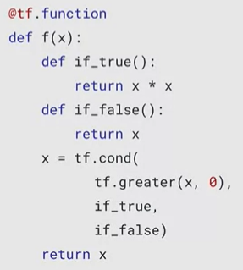

Graph have explicit dependencies. This makes it relatively easy to parallelize and distribute the computation. This allows for program optimizations.

Autograph is a technology that allows us to take our eager-style Pythonic code and automatically turn it into graphs and vice versa.

To get started with autograph, we can start with implementing a function that performs some operation in eager mode, as always. For example:

def add(a,b):

Return a+b

Then, we decorate the function by adding @tf.function in the line above your function definition. This is as if we would be wrapping the function into a pre-built tf.function, so the add function now has the features of tf.function:

@tf.function

def add(a,b):

Return a+b

Our decorated add function now has graph codes that we can look at. If we want to explore what the graph code would look like, we can use the following code:

print(tf.autograph.to_code(add.python_function))

We can compute the gradients on graph style code:

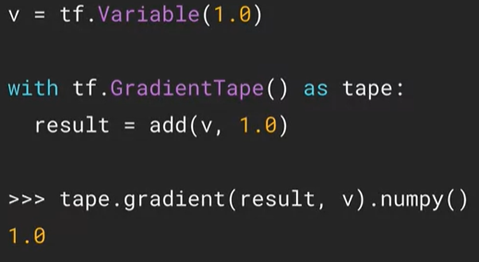

If the code uses multiple functions, we do not need to annotate them all. Any functions called from within an annotated function will also run in graph mode.

Python’s functions are polymorphic, which means that a function that takes in a function as parameter can work whether the parameter passed as an integer, float or even a string.

When defining a subclass of keras classes, we can also use graphs:

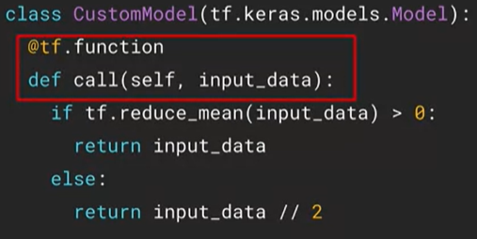

Codes that use lots of small operations (ifs, for, range, add, subtract, multiply, divide, comparisons, etc), tend to have the best performance improvement when coded in graph mode.

When working in graph mode, do not use print() but instead use tf.print()

The declaration of variables (v = tf.Variable(1.0)) must be done outside of the function

## Week 4: Distributed Training

Distributed training in tf is built around data parallelism, where we replicate the same model on multiple devices and run different slices of the input data on them

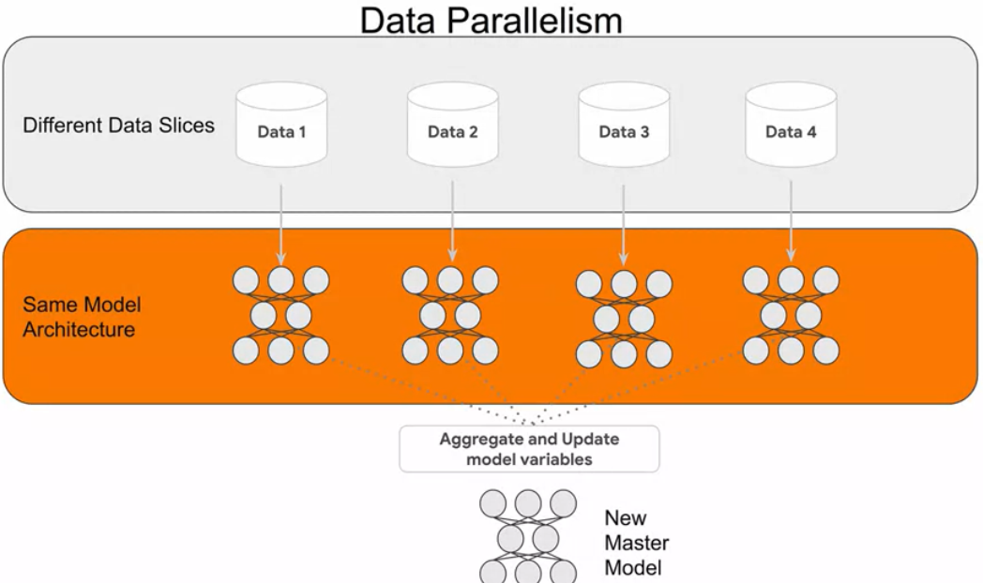

The heart of this is the tf.distribute.Strategy class. It supports eager mode and graph mode.

Terminology:

* Device: the machine that trains ML models. It can be a CPU, GRU or TPU
* Replica: during training, the copies of the model’s variables are placed on several devices. This copy is called a replica
* Worker: software running in a device that is dedicated to train the replica that is on that device
* Mirrored variable: even though some variables in the replicas are trained independently, there are some variables that we want to be in sync across all replicas. These variables are called mirrored variables

Parallelism can happen in the hardware platform: either in one machine with multiple devices (CPUs, GPUs and TPUs) or with multiple machines organized in a network (each machine can have different types and numbers of devices).

Parallelism can also happen in the training stage: synchronous training, where all workers work on different slices of input data in sync with each other and they aggregate gradients at each step using an all-reduce algorithm; asynchronous training, where all the workers are independently training over the training data and update the variables asynchronously.

Tensorflow supports a number of strategies to help us train the previously explained scenarios:

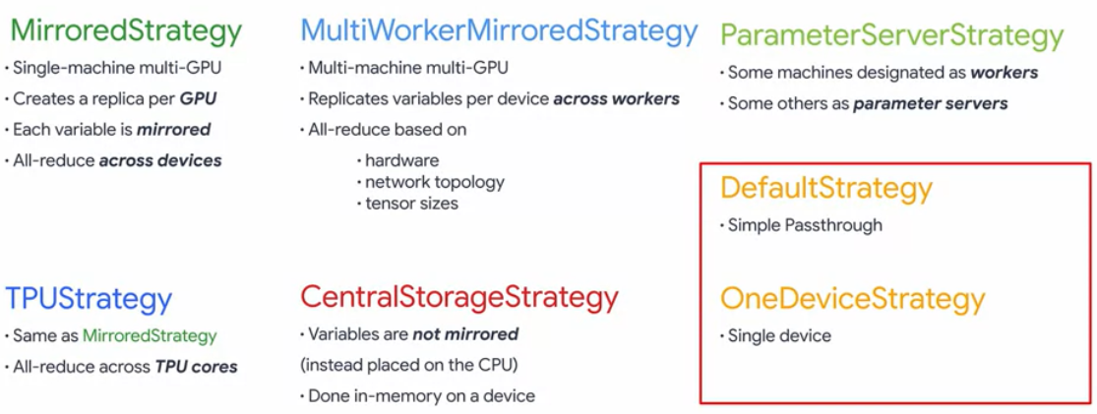

* MirroredStrategy: what people usually use when getting started. There is a single computer but supports multiple GPUs. It creates a model replica on each GPU and then mirror the variables. After each epoch of training, the learned parameters are merged using an all-reduce across each of the devices.
* TPUStrategy: similar to the MirroredStrategy, but uses TPUs instead of GPUs.
* MultiWorkerMirroredStrategy: Multiple machines on the network, each one with a variable amount of GPUs. It replicates and mirrors variables per device across workers. Then it uses an all-reduce algorithm based on the network setup. It is a very specific strategy that is customized to our network’s setup.
* CentralStorageStrategy: generally a single machine strategy. Instead of mirroring variables across the different GPUs, they are stored and processed by the CPU
* ParameterServerStrategy: there is a database with the variables or parameters such as weights, biases or filters which is stored in a central place. Some of the machines of the network will become workers that perform the training and some others are the parameter servers, where that database is stored. This helps to avoid having to replicate or mirror the variables, because all the variables are stored in the central parameter servers.
* DefaultStrategy: primarily used for prototyping the code on a single machine and we can then use them on a distributed platform. It is just a passthrough that allows us to create distributed strategy code without needing any of the supported backends, so we don’t need multiple GPUs, networks or machines
* OneDeviceStrategy: primarily used for prototyping the code on a single machine and we can then use them on a distributed platform. Explicitly places all of the training parameters, all the data and all the ops onto a single device. All will be funneled to that device

Mirrored Strategy

There are two places where we change the code to establish a mirrored strategy: in the model declaration and in the data preprocessing.

Typical Keras code for setting up a model for training without using any kind of distribution strategy:

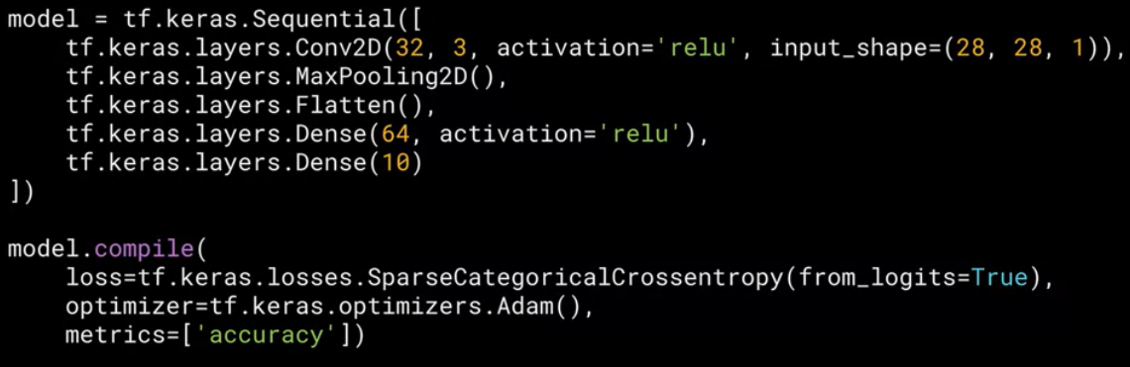

Typical code to prepare the data where we have a dataset that is loaded from tfds:

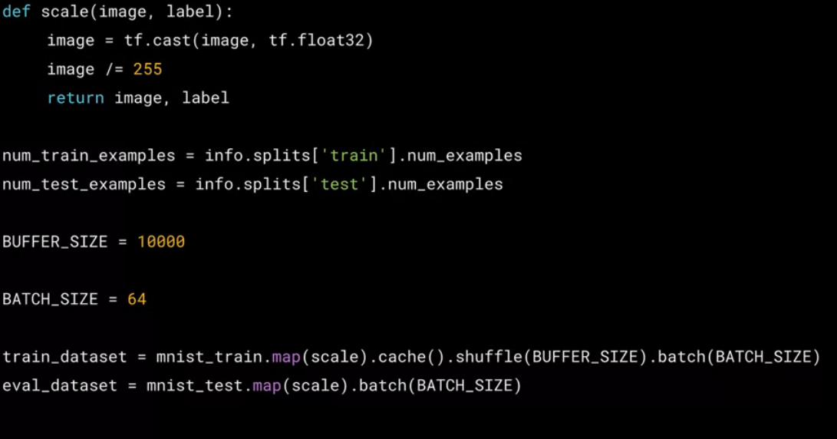

To modify this code to use the MirroredStrategy we do the following:

First we define which strategy we want to use by setting strategy = tf.distribute.MirroredStrategy()

The strategy object contains properties that describe the infrastructure. For example, we can get the number of available replicas by writing strategy.num_replicas_in_sync.

For the data preprocessing we define the BATCH_SIZE_PER_REPLICA instead of the BATCH_SIZE. Then, the BATCH_SIZE is defined as BATCH_SIZE_PER_REPLICA times the number of replicas that we want to keep in sync:

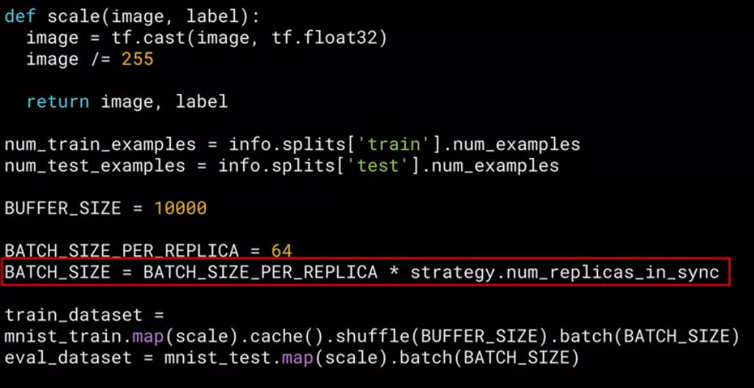

In this case, if we have 2 GPUs, each one of them will have 64 samples per batch, so we will have 128 samples in total per batch.

Then, for the model definition, we just need to make sure that the model is within the scope of the strategy by setting with strategy.scope(): at the beginning:

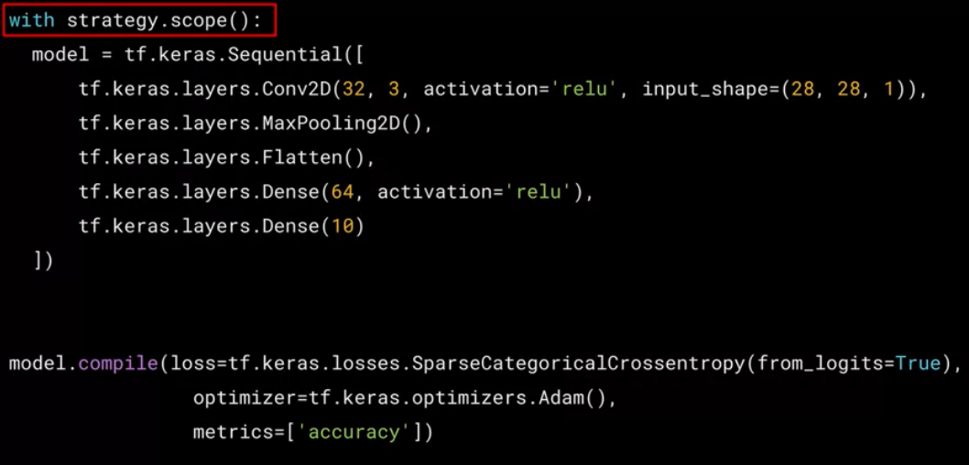

The model.compile() nor the model.fit() parts have to be within the strategy.scope(). Only the model declaration must be there.

The mirroredStrategy will create one replica for every GPU device and all the trainable variables are copied across these replicas, so they are mirrored variables. This means that after each forward pass, the variables are synced, so that they are the same across all the devices and replicas of the model.

Custom training for multiple GPU MirroredStrategy

To create distributed datasets from static datasets we use the function strategy.experimental_distribute_dataset() passing it in the dataset that we want to distribute:

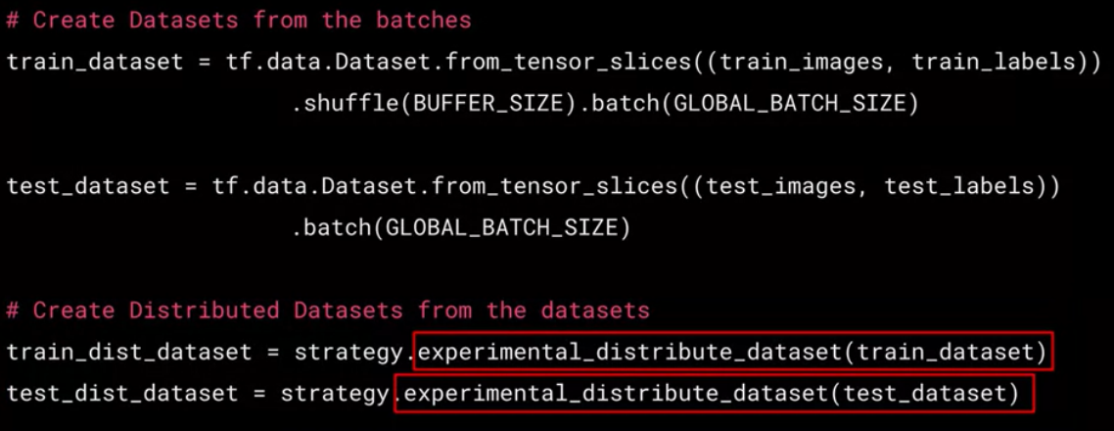

For the custom training using the distributed dataset we build a function called distributed_train_step(). The distributed_train_step will receive the losses from each of the replicas and then reduce them and then it will return that value.

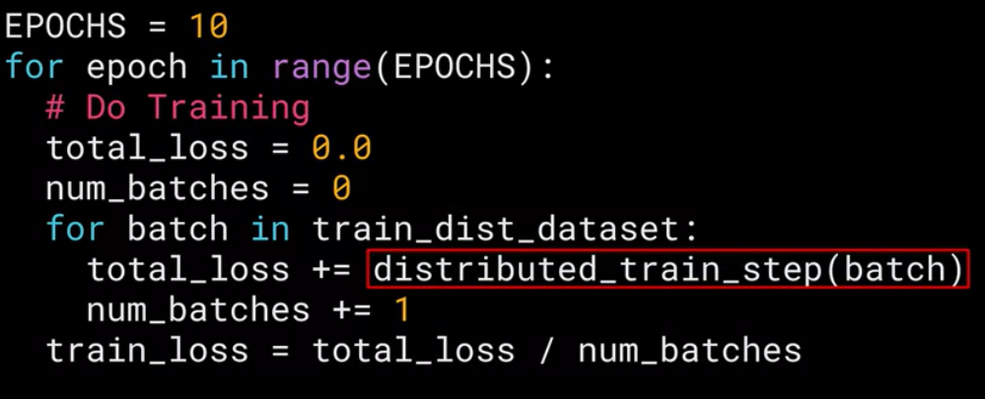

The function distributed_train_step() is shown here. The main training is done by the other additional function called train_step

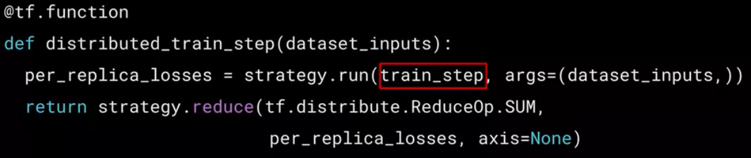

per_replica_losses contains the losses per replica

Then, strategy.reduce() method aggregates the losses. In this case it simply does a sum of the losses.

Finally, train_step is a regular training step:

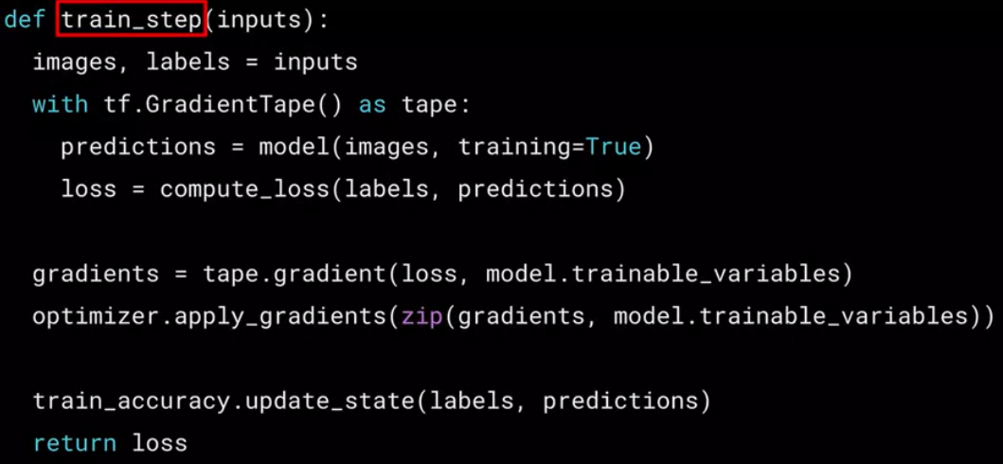

TPU Strategy

TPUs are chips that are optimized for machine learning.

It is good to start with the following code to get a handle on exactly what TPU resources are available:

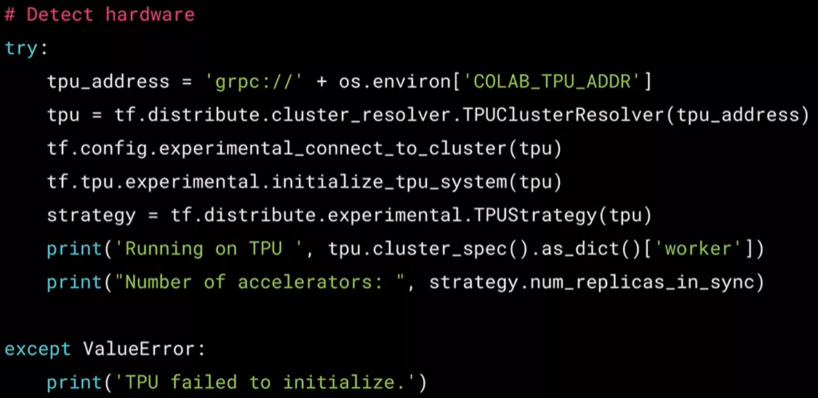

Training with TPUStrategy:

* Use a custom training loop instead of relying on Keras’ model.fit()
* Call the distributed training function within the loop
  + Use strategy.run to call our usual training function across all replicas
  + Results will be in per-replica-losses structure
  + Use strategy.reduce to reduce losses
* Call the distributed testing function within the loop
  + Use strategy.run to call our usual testing function across all replicas

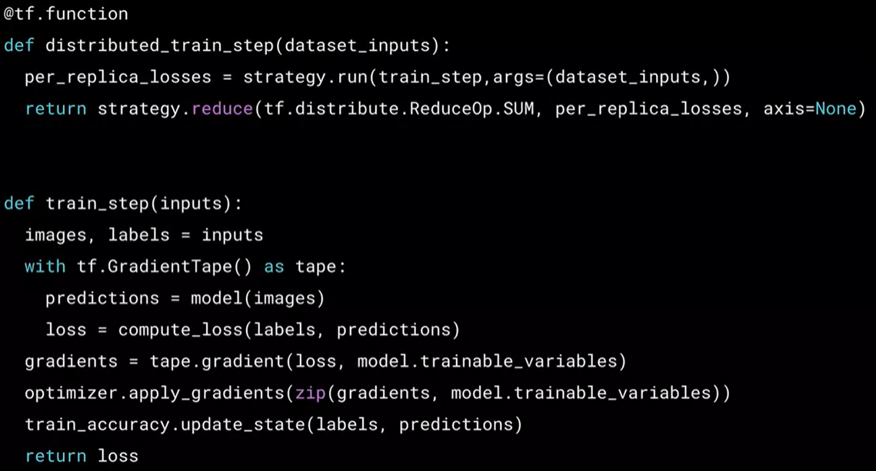

OneDeviceStrategy

This strategy is used when we deliberately wish to perform training on one specific device of our choice. While it is just one single device, the input data can still be treated as if it were distributed. So it can be used to test our code before we then distribute it across multiple devices.

To use it, we only need the name of the device we need to use: 

The rest of the code will work in exactly the same way as we’ve previously looked at.

MultiWorkerMirroredStrategy

When there are multiple GPUs on multiple machines and each machine can have a different number of GPUs on them. It is a complicated environment, so things like fault tolerance is vital and this can be achieved using checkpoints. If an issue happens during training, then we can revert to the most recent checkpoint. This is done by calling tf.keras.callbacksModelCheckpoint.

Synchronization and reduction is also more complex and is performed using something called CollectiveOps.

Tutorial: <https://www.tensorflow.org/tutorials/distribute/multi_worker_with_keras>

Example (2 machines, each one with 1 CPU and 2 GPUs)

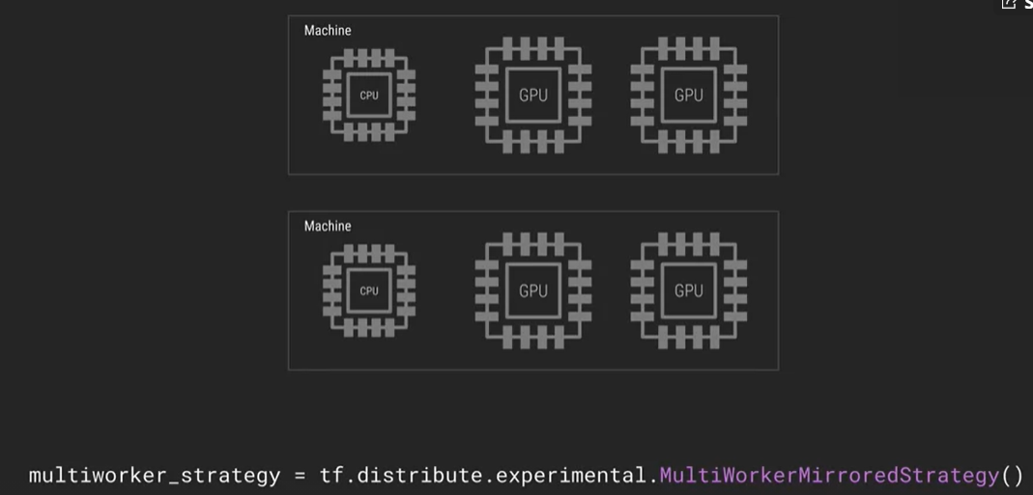

CentralStorageStrategy

The training variables are not mirrored across the clusters and instead they are stored in memory accessed by the CPU. However, the computation takes place on the GPUs with the idea of saving the more expensive GPU memory for computation only

ParameterServerStraregy

The computation is across all of the GPUs of the system but the variables are stored in a distributed database called a parameter server. Some machines are designated as workers, while some others are designated as parameter servers.

# Course 3: ADVANCED COMPUTER VISION WITH TENSORFLOW

## Week 1: Introduction to Computer Vision

Semantic segmentation: all the instances of the same class are segmented together (all persons in an image are treated as one segment). Popular models are Fully-CNN, U-Net, DeepLab

Instance segmentation: multiple instances of the same class are separate segments. Popular model is Mask R-CNN

Transfer learning options

1. Freeze the weights that have been transferred over from the pre-trained model. Only train the last layers (Fully connected layers and softmax). Good when we have relatively little data to train with.
2. Retrain entirely without freezing the convolutions but use the transferred weights as the starting point.

ResNet 50 is a 50 layer Deep Residual Network for Image Recognition

Example of transfer learning using Resnet50 (use Resnet50 as a feature extractor):

def feature_extractor(inputs):

feature_extractor_layer = tf.keras.applications.resnet.ResNet(

input_shape = (224, 224, 3),

include_top = False,

weights = ‘imagenet’)(inputs)

return feature_extractor_layer

We must specify the input shape as 224x224x3, since ResNet50 was built with images of this size. By specifying include_top to False will remove the top most layers from the model. The top of the model is the end with the predicted outputs.

By setting weights equal to imagenet, we use the weights that were learned when ResNet50 was trained with imagenet dataset.

Then, we can define the classifier:

def classifier(inputs):

x = tf.keras.layers.GlobalAveragePooling2D()(inputs)

x = tf.keras.layers.Flatten()(x)

x = tf.keras.layers.Dense(1024, activation = ‘relu’)(x)

x = tf.keras.layers.Dense(512, activation = ‘relu’)(x)

x = tf.keras.layers.Dense(10, activation = ‘softmax’, name = ‘classification’)(x)

return x

And finally we combine both parts of the network:

def final_model(inputs):

resize = tf.keras.layers.UpSampling2D(size = (7,7))(inputs) #The images we want to classify are 32x32 but the ResNet50 needs images of size 224x224

resnet_feature_extractor = feature_extractor(resize)

classification_output = classifier(resnet_feature_extractor)

return classification_output

Simple network for object localization and classification:

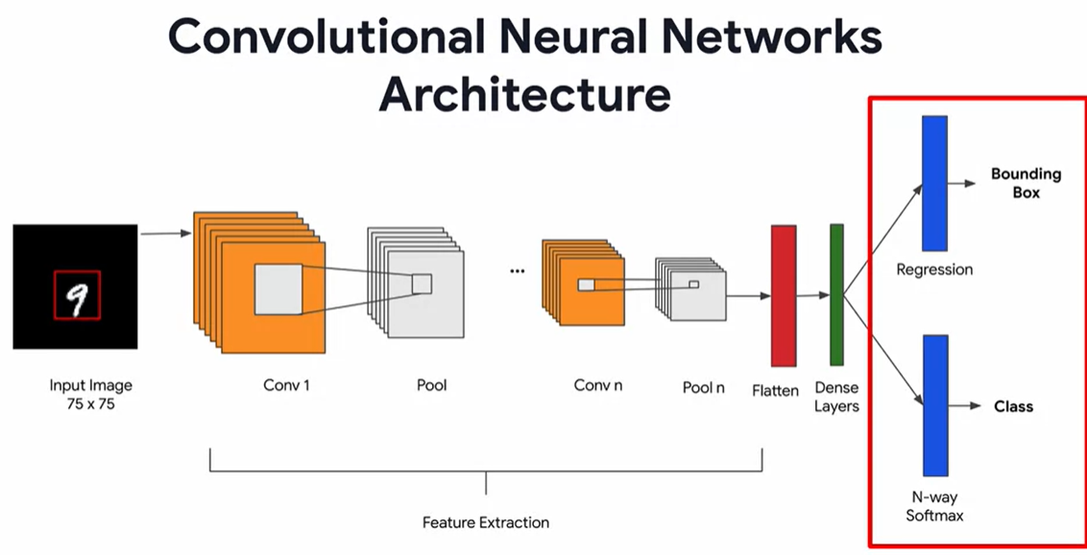

For the layer that predicts the bounding box, it will be a regression of 4 values (xmin, xmax, ymin and ymax). We don’t use an activation function for this last Dense layer.

To evaluate object localization, we can use the Intersection Over Union (IoU) metric:

IoU is defined as:

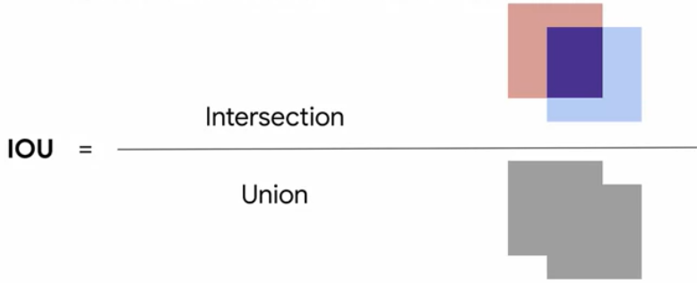

The IoU is a metric that goes from 0 to 1, where 1 is a perfect match.

## Week 2: Object Detection

Two stages of object detection: region proposal; and object detection and classification

R-CNN (Region CNN)

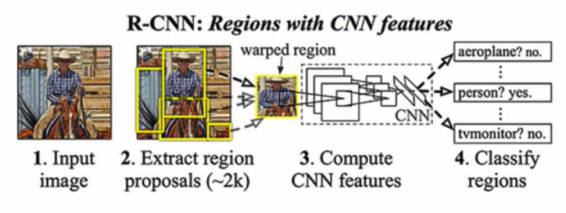

First, the R-CNN takes an input image. Then, it extracts region proposals. Each region proposal is a grouping of smaller segments using the selective search method (sliding window). The model will propose around 2k of those regions. Third, the model extracts features from these regions using a pre-trained CNN (in this case it uses Alex Net). To classify these features, the model uses SVM.

One drawback with the original R-CNN is that it is not very fast. Finding the areas using selective search is computationally expensive. So, another proposed architecture appeared called Fast R-CNN

Fast R-CNN

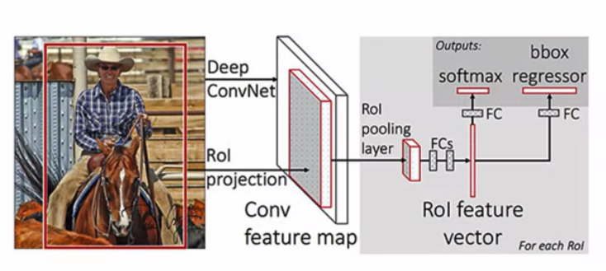

First an image is fed to the network along with a set of region proposals. Instead of using selective search to generate several region proposal for the image, Fast R-CNN expects these region proposals as inputs and it does not generate them itself. The CNN processes the image and outputs a set of features. The next step is to use the input region proposals and extract the region of interest from the feature map and create what is called a region proposal feature map: one for each region. This process is the region of interest projection. Then the region proposal feature map is downsampled with the help of a region of interest pooling layer to get a fixed length feature map of a consistent height and width (this means that all the regions of interest are at this point resized to the same size). Finally this feature map is flattened, passed through FC layers and generate the two outputs (class and bounding box location).

Faster R-CNN

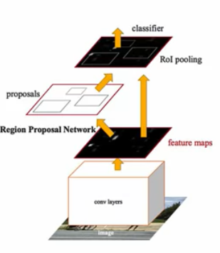

Faster R-CNN is an extension to Fast R-CNN with an addition of a region proposal network to propose regions of interest in the region proposal feature map. A Region Proposal Network (RPN) is a fully CNN (only uses convolutions and not dense layers), so we can simultaneously predict object bounds and object scores for each pixel. The RPN is designed to generate region proposals, which are used by Fast R-CNN for detection.

The entire image is fed into a CNN. This feature map has a sliding window that goes across the image to find areas of interest and a new entity called the RPN is used to find and create anchor boxes on the image. The center of the anchor box comes from the coordinates of the sliding window and the boundaries of the box comes from the RPN.

Example of using pretrained faster R-CNN:

If we go to tensorflow.org/hub, we see the available pre-trained models. We can select there a model and then copy the URL to download the model, then paste that url into our code:

import tensorflow_hub as hub

module_handle = URL COPIED FROM tensorflow.org/hub

detector = hub.load(module_handle).signatures[‘default’]

image_url = URL OF IMAGE TO BE ANALYZED

downloaded_image_path = download_and_resize_image(url = image_url,

new_width = 3872,

new_height = 2592)

img = tf.io.read_file(downloaded_image_path) #The image must be stored as a tensor

img = tf.image.decode_jpeg(img, channels=3)

converted_img = tf.image.convert_image_dtype(img, tf.float32)[tf.newaxis, …] #To convert the tensor to a 4D tensor of type float32

result = detector(converted_img)

We get 3 outputs. The first is the probability of the detected class, the second is the class and the third the bounding box

Object detection API

To get the API, we must clone into the TensorFlow models directory on Github:

!git clone --depth 1 <https://github.com/tensorflow/models>

This will generate a folder models into the content directory. Inside models there is the research folder and inside an object_detection folder

To install the API (%%bash):

sudo apt install -y protobuf-compiler

cd models/research/

protoc object_detection/protos/*.proto --python_out=.

cp object_detection/packages/tf2/setup.py .

python -m pip install .

After this is executed, the API is installed and we will see object detection libraries. Three very useful ones are:

from object_detection.utils import label_map_util: assigns index numbers to category names

from object_detection.utils import visualization_utils as viz_utils: to draw bounding boxes

from object_detection.utils import ops as utils_ops: utility functions that are used by the other two libraries

To use label_map_util, we do:

PATH_TO_LABELS = ‘./models/research/object_detection/data/mscoco_label_map.pbtxt’

category_index = label_map_util.create_category_index_from_labelmap(PATH_TO_LABELS, use_display_name = True)

category_index will be a dictionary where the keys are unique integers and the values are dictionaries that contain the class names

To use viz_utils, we do:

viz_utils.visualize_boxes_and_labels_on_image_array(image=…, boxes=…, classes=…, scores=…)

When we run the model and it returns its predictions, we get a dictionary of key-value pair where the values are tensor objects:

results = hub_model(image_np)

result = {key:value.numpy() for key,value in results.item()}

The keys of results are detection_scores, detection_keypoint_scores, detection_classes, detection_keypoints, num_detections, detection_boxes.

So,

viz_utils.visualize_boxes_and_labels_on_image_array(

image = image_np_with_detections[0],

boxes = result[‘detection_boxes’][0],

classes = (result[‘detection_classes’][0] + label_id_offset).astype(int),

scores = result[‘detection_scores’][0],

catefory_index = category_index,

use_normalized_coordinates = True,

min_score_thresh = .40

)

## Week 3: Image Segmentation

An image segmentation basic architecture is an encoder-decoder: 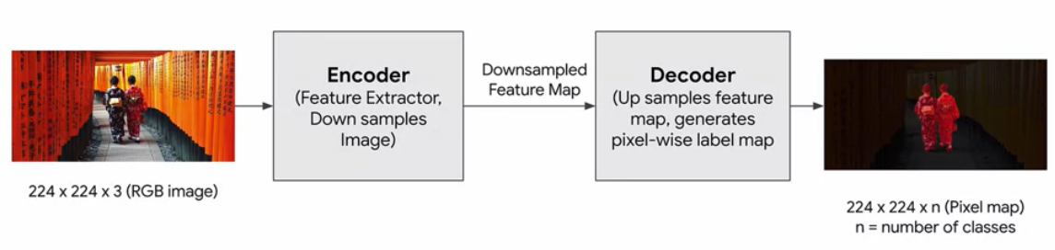

Encoder: CNN without fully connected layers. Aggregates low level features to high level features.

Decoder: Also a CNN. Replaces fully connected layers in a CNN. Upsamples image to original size to generate pixel mask.

Popular architectures for segmentation: Fully convolutional Neural Networks, SegNet, UNet, PSPNet, Mask-RCNN

Fully convolutional Neural Networks

Replace fully connected layers of CNNs with more convolutional layers. Earlier convolutional layers act as an encoder, which detects features and downscale the image. Later convolutional layers act as a decoder, which decodes and upsample the image creating a pixel-wise labeled map.

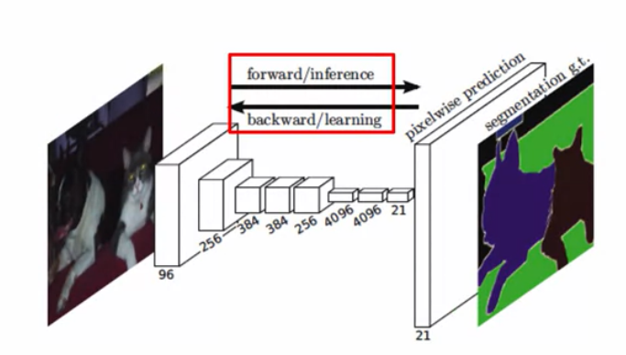

We can reuse the layers of well-known object recognition/detection models, since those layers are per se feature extractors

Segnet

Similar to Fully Convolutional Neural Networks, but the encoder layers are symmetric with the decoder layers with the same number of layers and arrangement

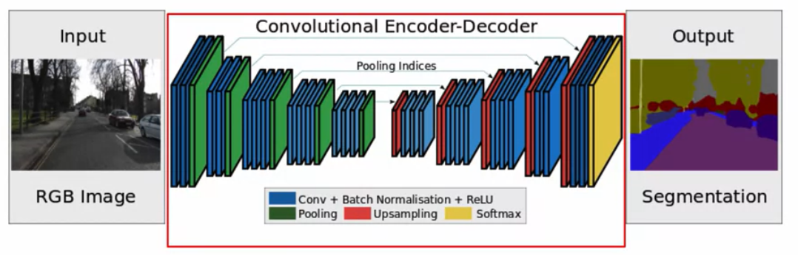

Unet

It is also symmetric meaning that the number of stages of upsampling and downsampling are equal

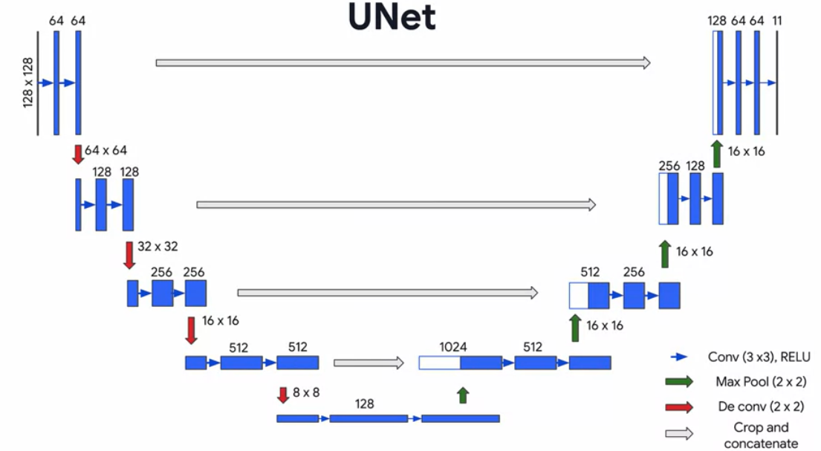

More details later

Mask R-CNN

It builds upon the faster R-CNN from before. It adds an additional branch after the feature extraction to perform upsampling to produce pixel-wise mapping

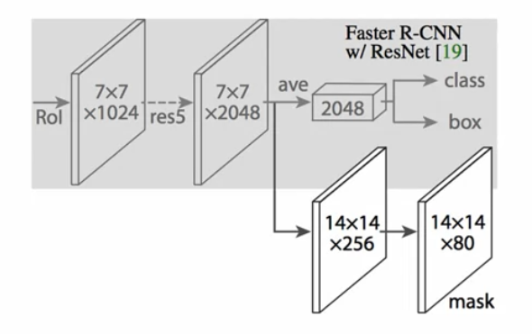

Upsampling

Upsampling can be done with two different keras layers:

* UpSampling2D: does simple scaling

Two types of scaling:

* + Nearest: Copies value from the nearest pixel
  + Bilinear: Bilinear interpolation of nearby pixels

x = UpSampling2D(size = (2,2), data_format = None, interpolation = ‘nearest’)(x)

* Conv2DTranspose: Transposed convolution (deconvolution)

x = Conv2DTranspose(filters = 32, kernel_size = (3,3))

Dice score: $2\frac{Area of overlap}{Combined area}$

IoU score: $\frac{Area of overlap}{Area of union}$

The Dice score tends to veer towards the average performance and the IoU score helps understand the worst-case performance.

U-net

U-net is also a Fully Convolutional Neural Network



The key difference is that, in addition to the up-sampling path, skip connections between the encoder and the decoder are also used

The encoder part is composed of convolution layers and downsampling using maxpooling. From the first level to the end of the encoding (5th level), an image of size 128x128 is filtered and downsampled into 8x8 blocks

An additional simple convolutional layer is used afterwards. It is called bottleneck and does not have pooling.

The decoder part upsamples the 8x8 image using the same sizes of kernels as the encoder part. However, at each layer, we take the convolution outputs of the same level of the encoder and we concatenate those convolution outputs with the convolution outputs of the decoder. We use those feature maps to upsample the image and so on.

Finally, the output segmentation map is obtained by performing 1x1 convolution with the filters equal to the number of classes

Instance segmentation

Detection of individual classes and separate them into distinct examples of each. With instance segmentation we don’t just generate the segmentation maps, but we also find out how many instances of each kind of object identified appear in the scene.

## Week 4: Visualization and Interpretability

Class activation maps

A class activation map is a matrix that shows what parts of the image the model was paying attention to when deciding what class to assign the image. It’s a map of which pixels of the image sent activations that we use to determine the class of the object.

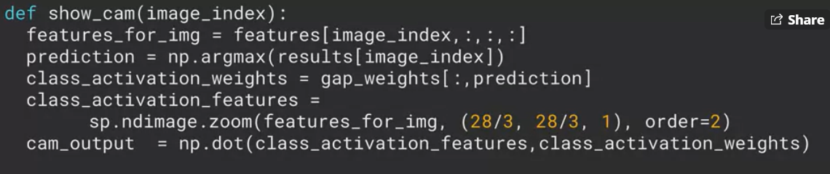

We basically take the outputs of the final convolutional layer of a CNN and them multiply them up with their class activation weights and then zoom them back up to the original size image before superimposing on the image.

Another way of understanding it is: we look at the outputs of the final layer of convolutions, stack them on top of each other to get the overall map and then scale that up to superimpose it on the original image.

To generate the class activation map, we want to get the features detected in the last convolution layer and see which ones are most active when generating the output probabilities. We can get the CAM by getting the dot product of the class activation features and the class activation weights

Saliency

We can also generate a saliency map, which is a representation of every pixel in the image in a way that makes sense for our particular context. In this sense, it is defined by the pixels in the image that end up having an impact on the classification of the image. In the saliency map, the pixels that have an impact in the classification are highlighted.

This differs slightly from a class activation map in that would just show the relevant pixels as opposed to the location of detected features in the image where those features impacted the classification.

The main difference is that in saliency maps, we are just shown the relevant pixels instead of the learned features.

We can generate saliency maps by getting the gradient of the loss with respect to the image pixels.

This means that the changes in certain pixels that strongly affect the loss will be shown brightly in our saliency map

We look at the gradients of the final layers to see which ones have the steepest curve. And from there we can figure out their location and plot them on the original image.

To compute the saliency of an image with respect to a particular class, we compute the gradients of the loss with respect to the input image. This tells how the loss value changes with respect to a small change in the input image pixels:

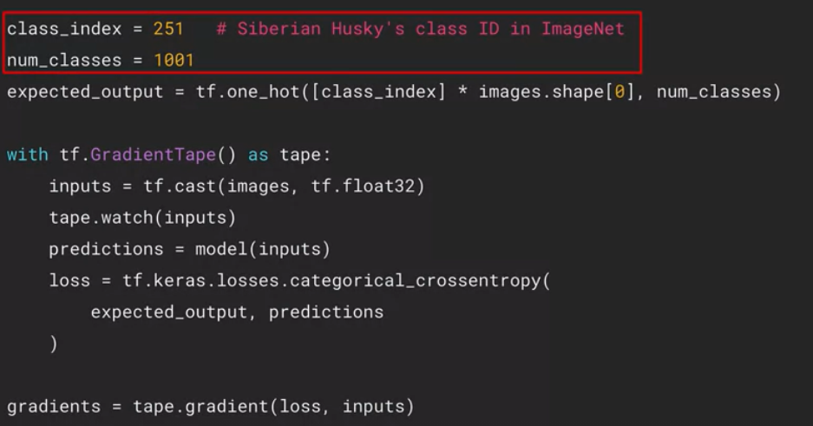

Then, to plot the values we get from the gradients:

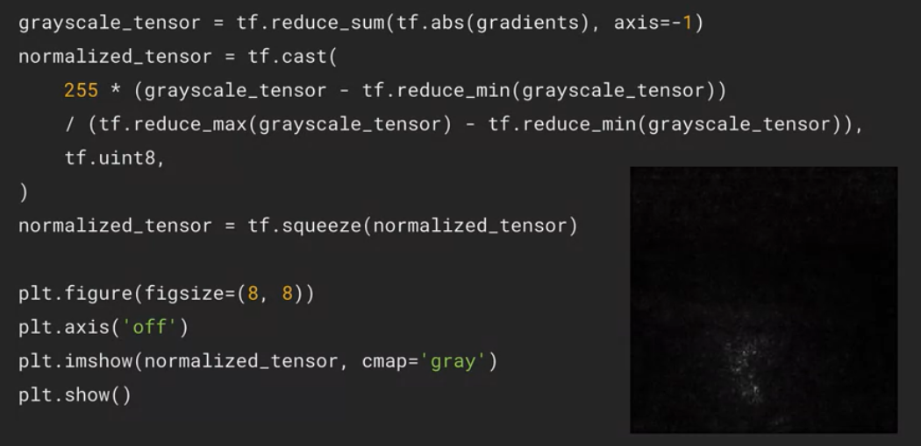

GradCAM (Gradient Weighting Class Activation Mapping)

GradCAM is basically combining class activation maps and saliency maps. It is a class activation map that uses the gradients of the final classifications.

GradCAMs uses gradients instead of the global average pooling weights to weight the activations

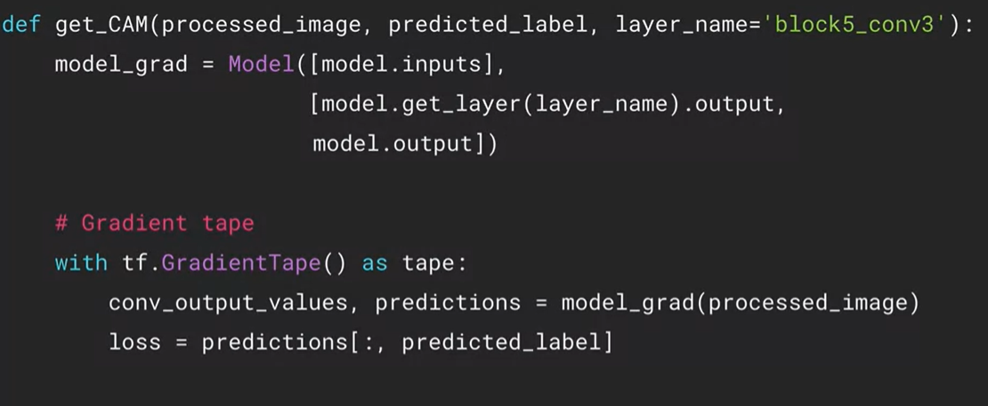

We compute the gradients of the loss with respect to the last layer’s output, we average them out across all the feature maps:

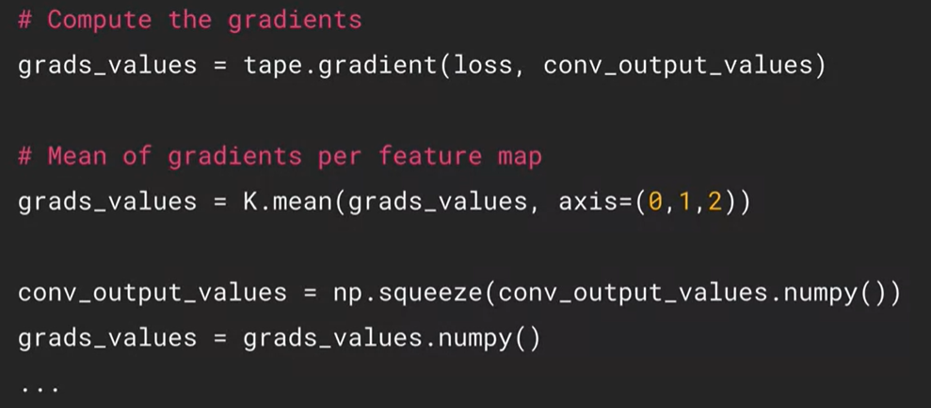

Finally, we can iterate over the features from the final convolutional layer and scale them with the respective gradients.

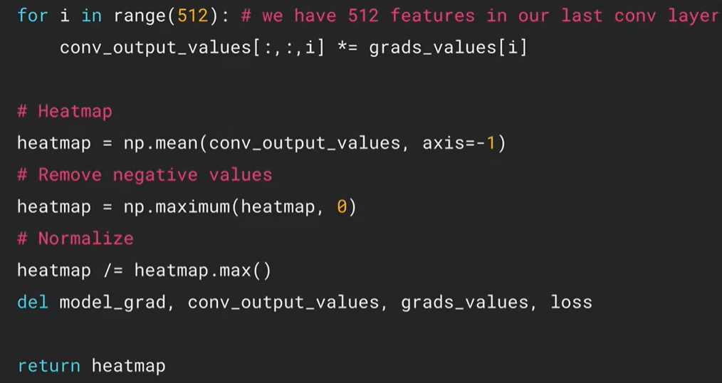

ZFNet

A model obtained by fine-tuning AlexNet.

To do unpooling it is necessary to save the location of the max pixel when doing the pooling, so that when we unpool, we know in which part of the image the max pixel was:

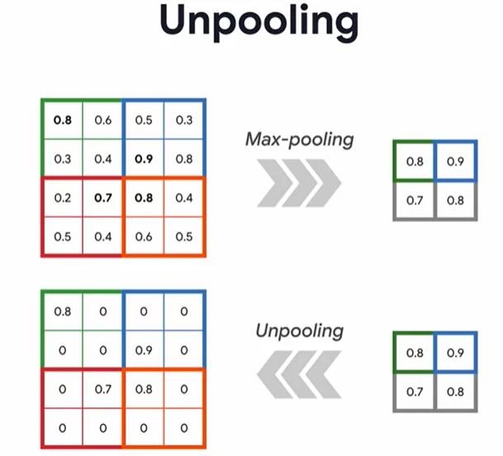

This usage of the locations of the pixels where the maximums were is called switching:

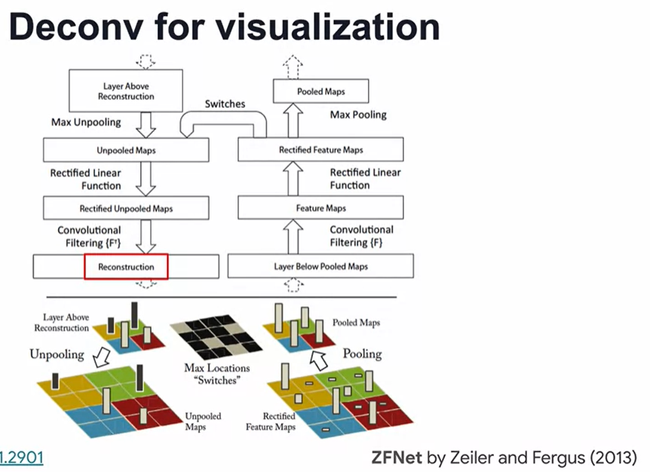

Applying this to the layers of AlexNet, two notable modifications were made in layers 1 and 2, building ZFNet: For instance, layer 1 filter size was reduced from 11x11 to 7x7 with stride of 2 instead of 4

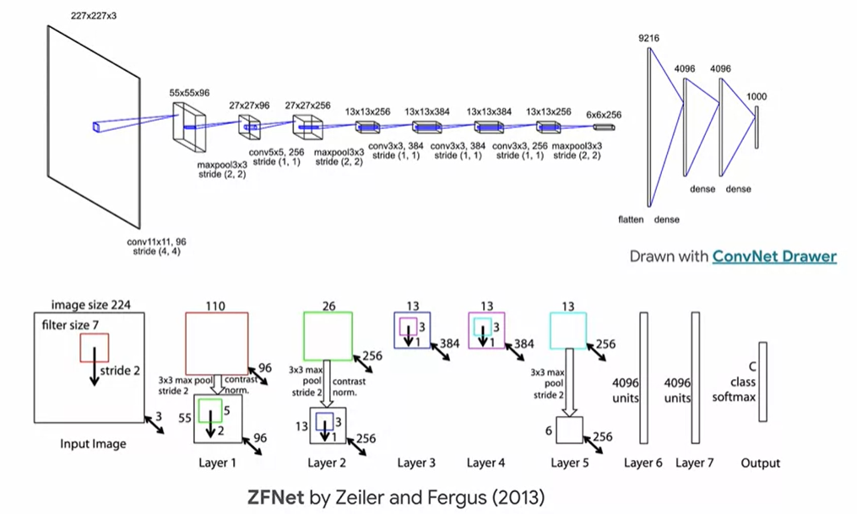

# COURSE 4: GENERATIVE DEEP LEARNING WITH TENSORFLOW

## Week 1: Style Transfer

Neural style transfer: we start with a pre-trained model.

It is very convenient that the model can train itself with a single pair of images: we use the model to extract the style from image 1 and also to extract the content from image 2. Then, we create an image with the elements of both images (style from image 1 and content from image 2). We do this iteratively in a loop minimizing a loss function.

How does style transfer work?

We have the image that we want to transform (the content image). We also have the image that gives us the style that we want (the style image).

Using a pre-trained CNN we can extract the content features from the content image. We represent these features as the last block in the network. The style is also extracted using a pre-trained CNN. Style information can be extracted from every layer in the network.

Then we initialize the generated image from the content image. The model can compare the generated image with the content image by calculating the content loss. Similarly, the model can compare the generated image with the style image by calculating the style loss. The style loss and content loss are combined in a total loss. We then update the generated image with gradients with respect to the total loss.

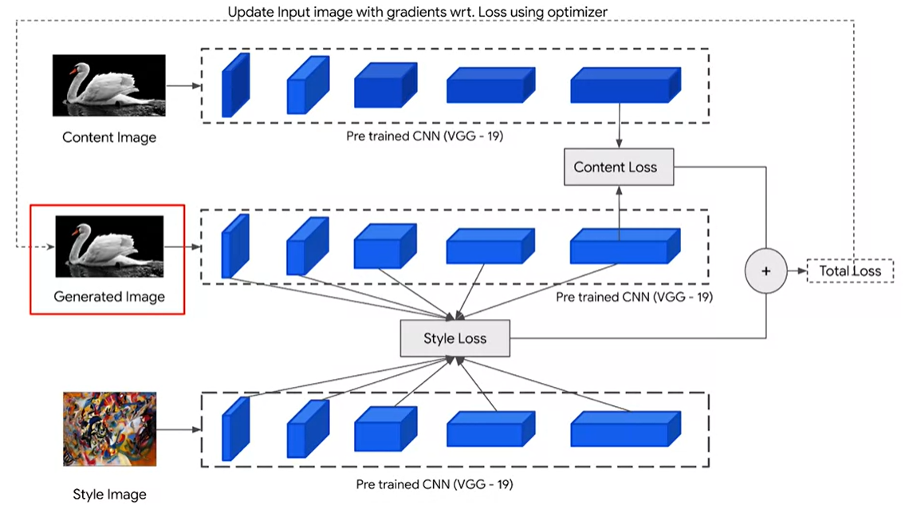

An advantage of this is that only a single pair of content image and style image is required. However, a disadvantage is that many passes are required to style the image.

A faster way of building this is explained in the paper “[Perceptual Losses for Real-Time Style Transfer and Super Resolution](https://cs.stanford.edu/people/jcjohns/eccv16/)”.

The algorithm goes through these steps:

1. Preprocess, content & style images.

VGG-19 is a pretrained model imagenet. To use this network, we need images with pixels to be centered around 0.

This can be done with the function

image = tf.keras.applications.vgg19.preprocess_input(image)

Then, we must extract style and content features. This is done with the help of CNNs. Lower level features define the style of the image and higher level images define the content of the image. This means that the style is extracted from the lower numbered CNN layers (closer to the input) and the content is extracted from the higher numbered layers (closer to the output):

Style:

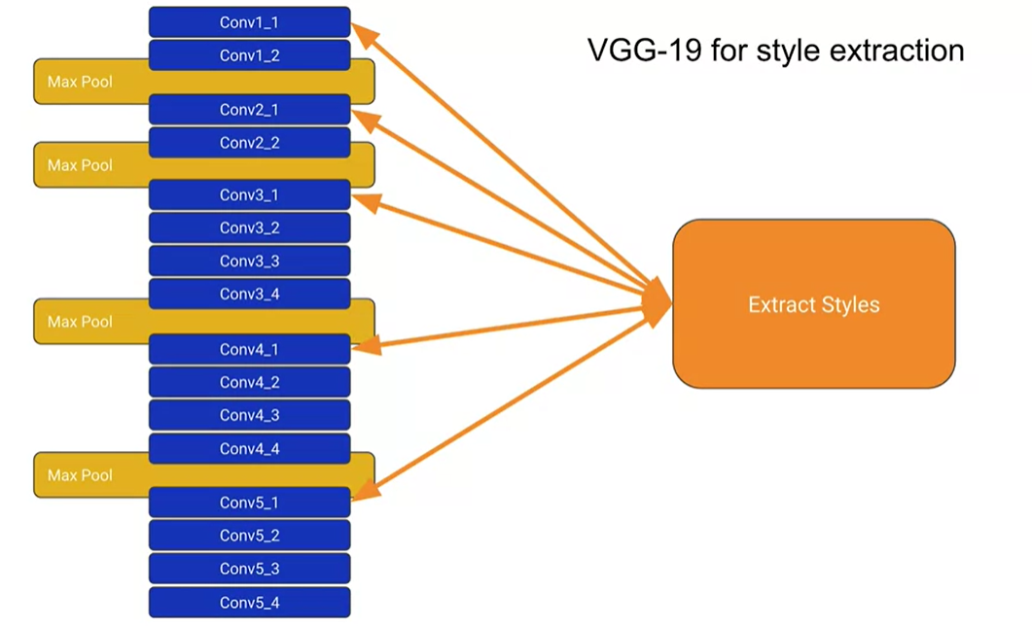

Content:

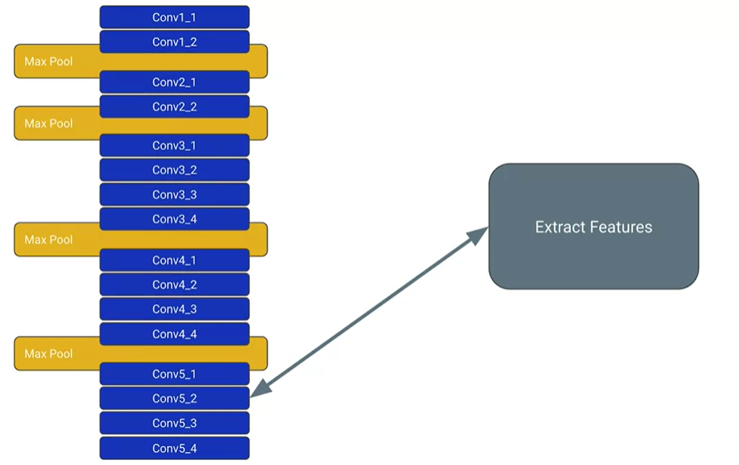

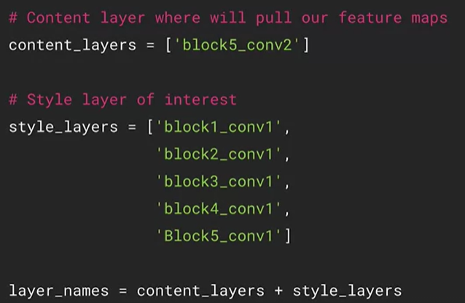

1. Load pre-trained model and define loss functions.

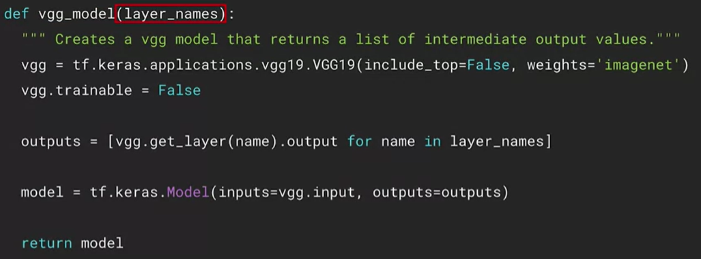

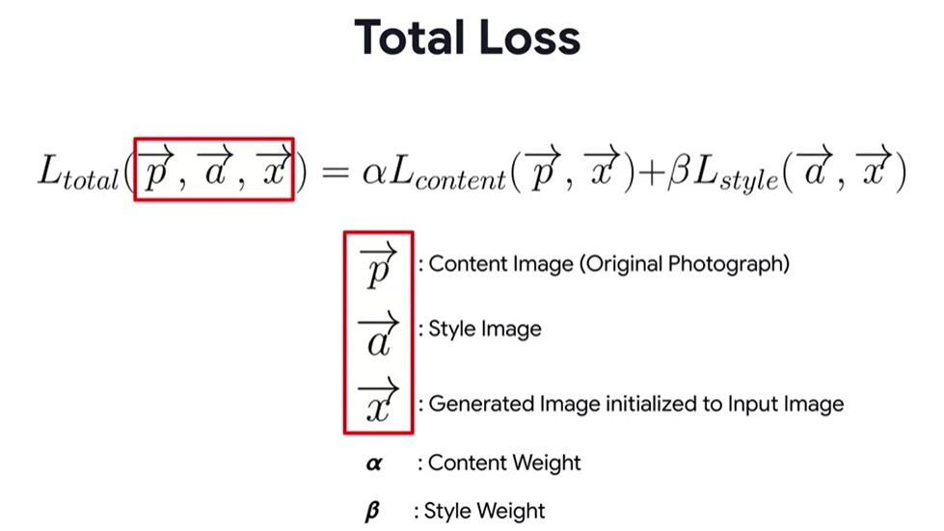

Content loss:

To calculate the content loss, we take the content features from the generated image and compare them with the content features from the content image. Then, we take the element-wise differences of these features and then take the square of these differences. Finally, do the reduce sum of these numbers:

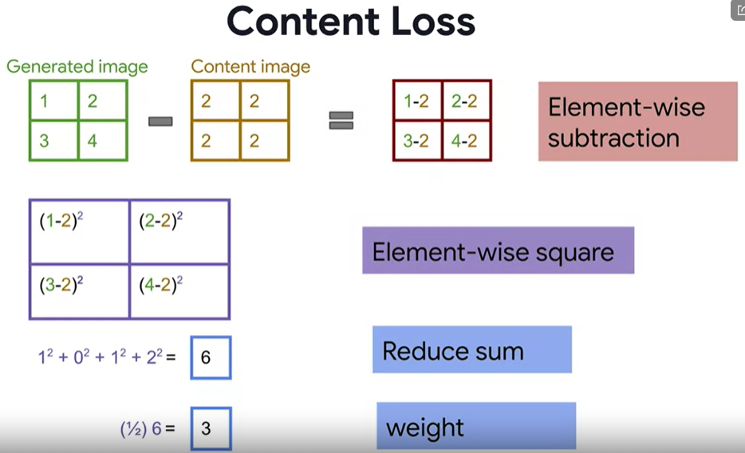

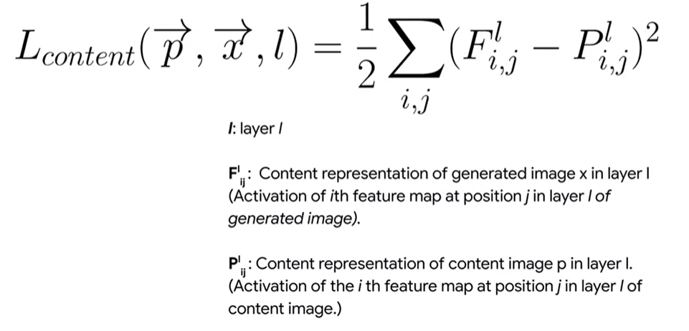

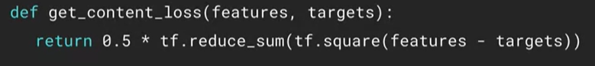

Style loss:

To calculate the style loss, we use the same pattern

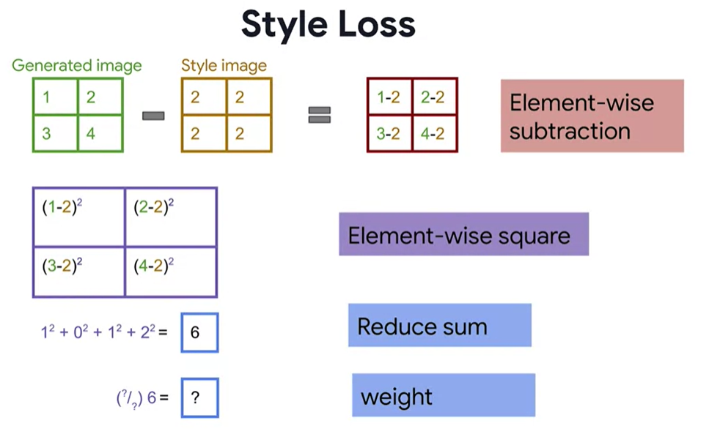

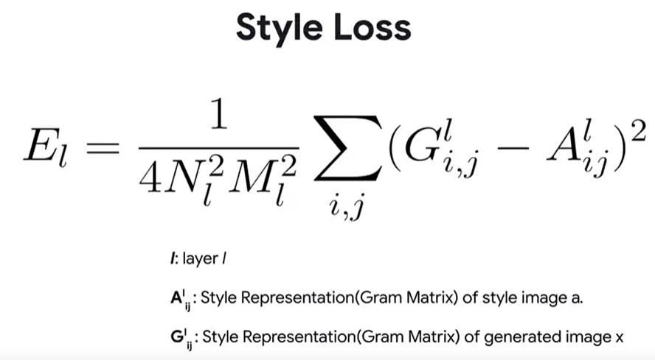

The style loss is calculated across a different number of layers, so we calculate the loss E_l at each layer l.

We use here Gram matrixes, instead:

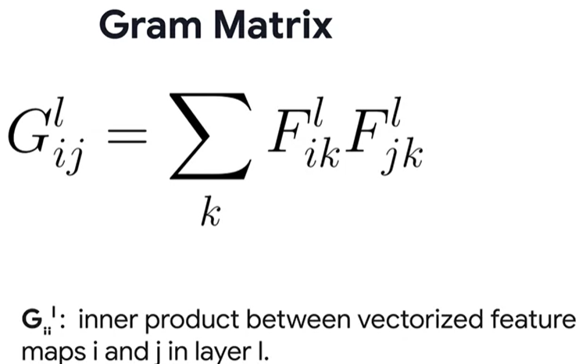

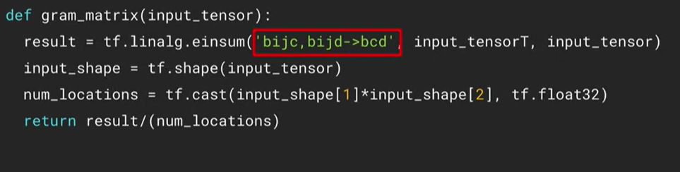

What is inside the red square is called “Einstein Notation”, and it is used to easily code the Gram Matrix

To get the Gram matrix for each of the style layers:

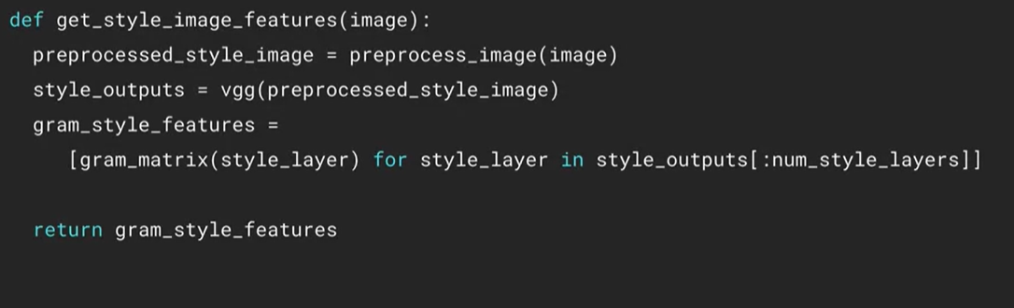

Finally, the style loss is

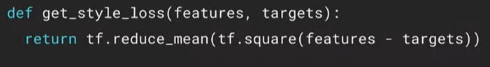

And the total loss can be calculated by doing:

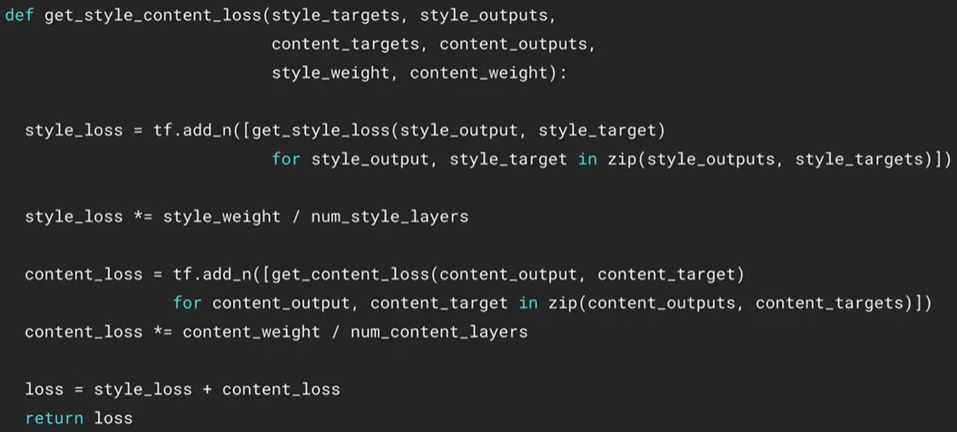

1. Loop
   1. Optimize and generate new image.

The styling loop looks like:

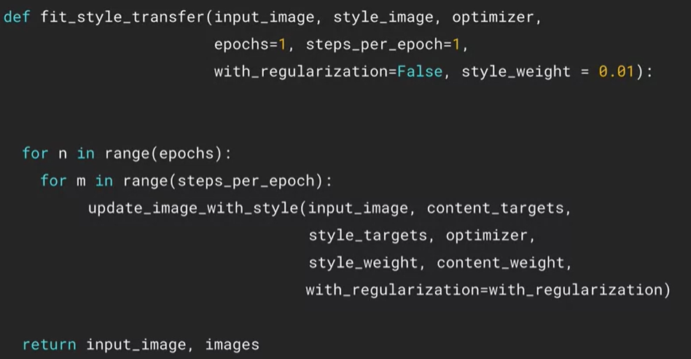

Where

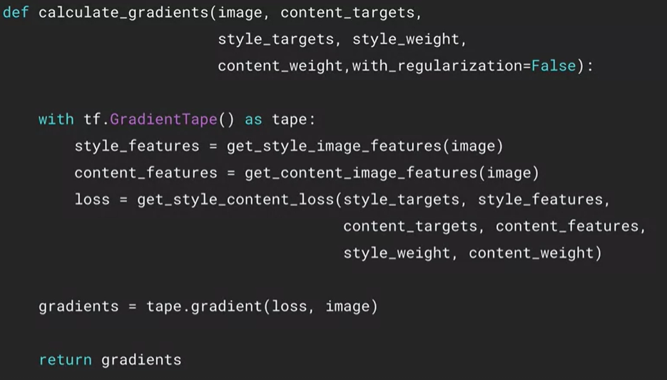

And

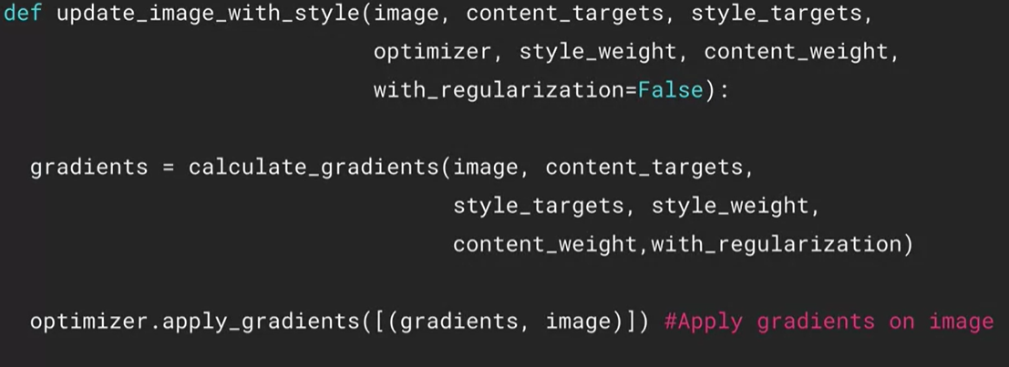

* 1. Visualize the output.

After we generate the image, the generated image will probably have edges and ridges, while the original image was smoother. To remove these artifacts, we can use edge detector filters known as high pass filters. A high pass filter smooths out the image by only allowing values above a certain threshold through.

To decrease these high frequency artifacts, we can do it on the loss function with an update to make it something called a total variation loss. Its goal is to decrease the high frequency artifacts and apply regularization on the components that have high frequency values.

We can calculate the total variation of the image using a function in tf.image that implements the algorithm for us:



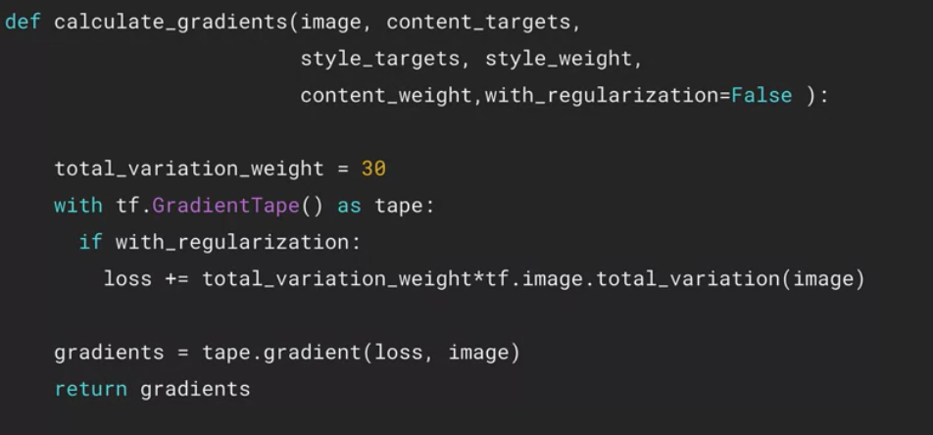

Fast Neural Style Transfer can be downloaded using TensorFlow hub.

## Week 2: Autoencoders

An autoencoder is a neural network that is able to learn dense representation of input data without supervision. They are very useful for dimensionality reduction and visualization. They can also be used to create new data that resembles the input data. The idea is to create another representation of the data

When creating an autoencoder, the architecture can look something like this:

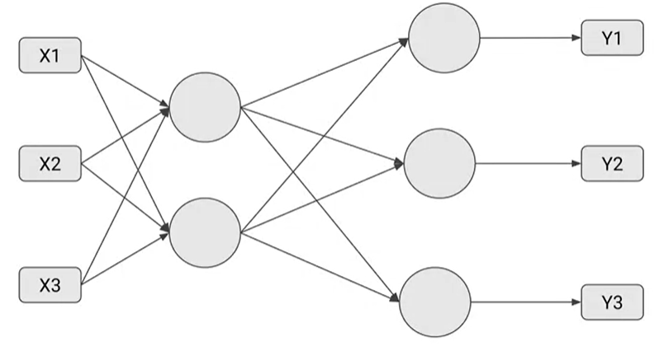

Note that the number of output neurons should be the same as the number of inputs. The first layer will encode the latent representation of the input data, so it is called the encoder. The layer that decodes the latent representation is called the decoder. In this case, we encode 3D data into 2D data, which is then decoded back to 3D data.

To create the previous autoencoder, we can do:

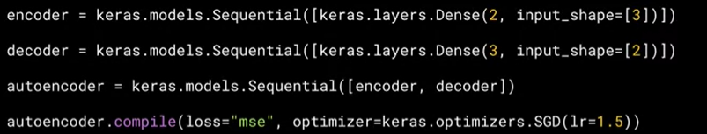

In this case, we fit the training data to itself:



Then, to generate the codings, we do:



And to decode the codings, we can do:



More complex autoencoders need multiple layers for the encoder and the decoder and not only one. These are called stacked autoencoders:

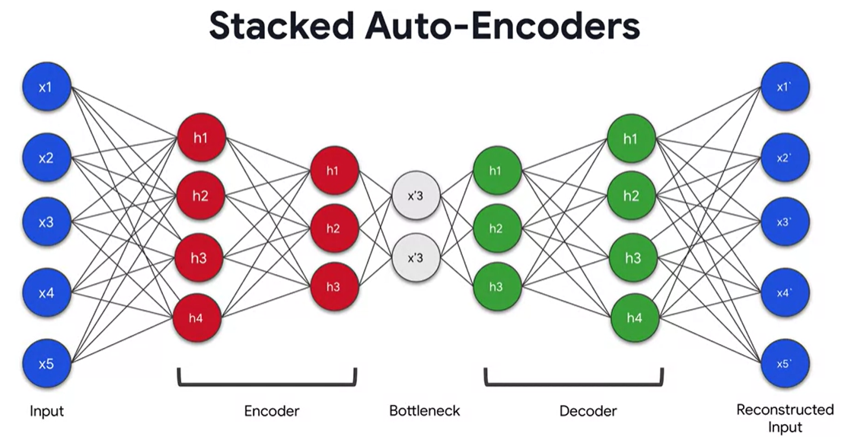

Autoencoders can also have Convolutional Layers

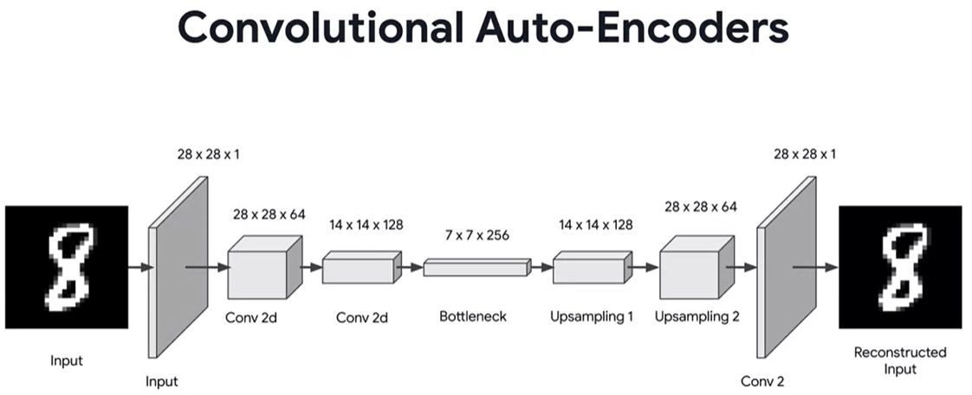

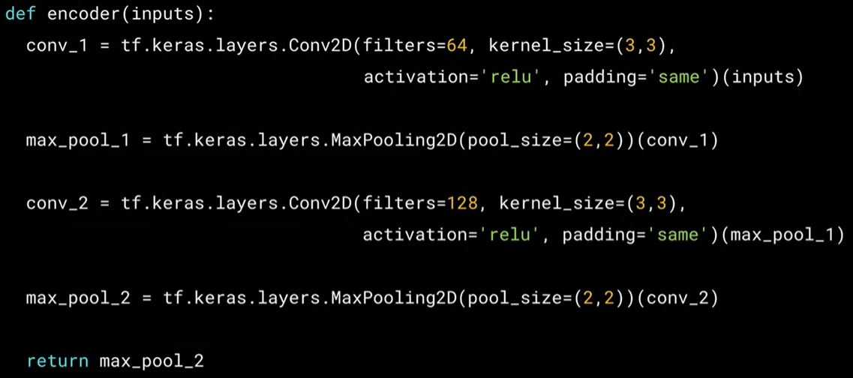

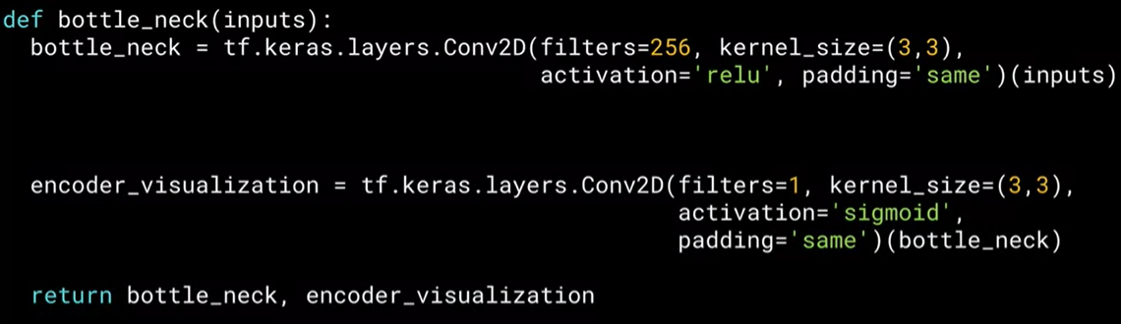

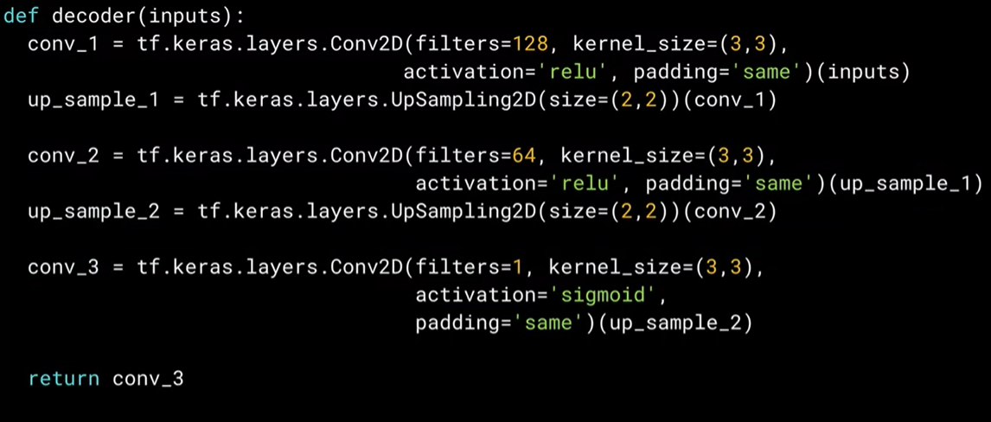

All combined:

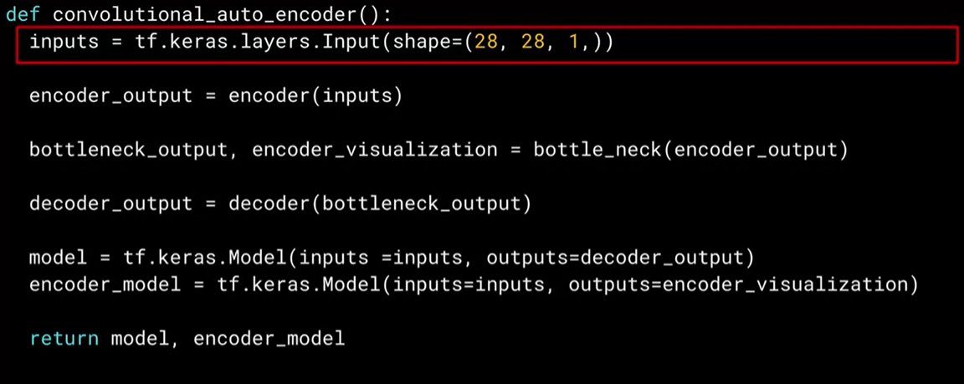

CNN autoencoders work also very good with noisy data. They can denoise the input image to generate a new image without noise.

## Week 3: Variational Autoencoders

A normal autoencoder has the following structure:

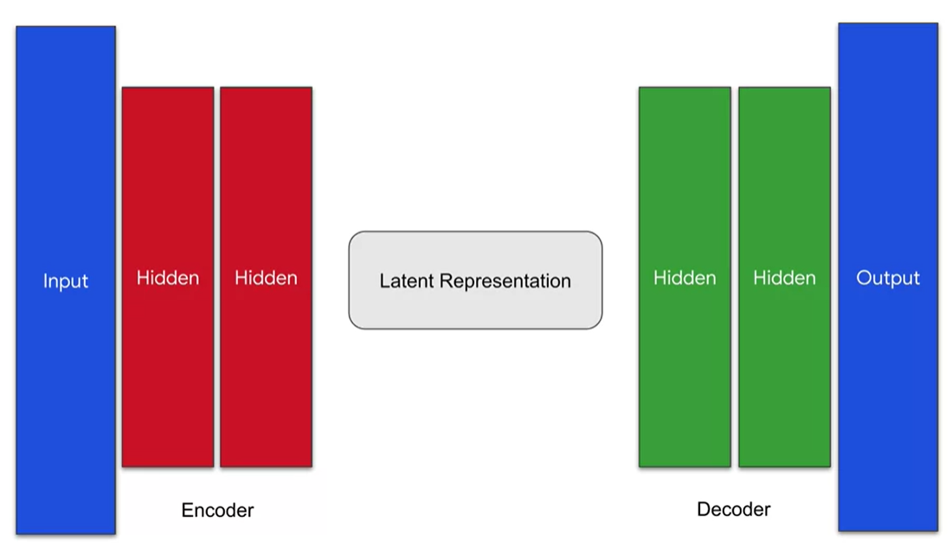

A Variational Autoencoder (VAE) can be used to create new data that resembles the input data but is not “exact” like the input data. Variational Autoencoders focuses on the Latent Representation. With Variational Autoencoders, the latent representation is now more probabilistic:

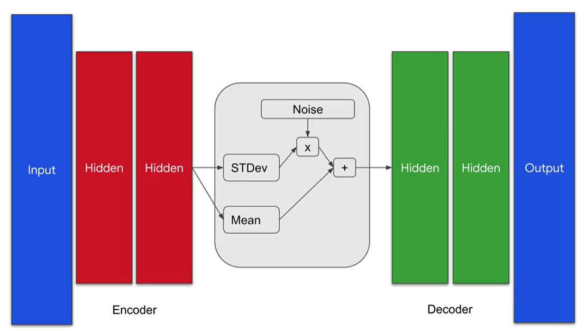

Instead of taking the output of the encoder as the latent space, we now take 2 outputs from the encoder: mean encoding and standard deviation encoding. Noise is also added by multiplying it to the standard deviation and then adding that to the mean.

Example:

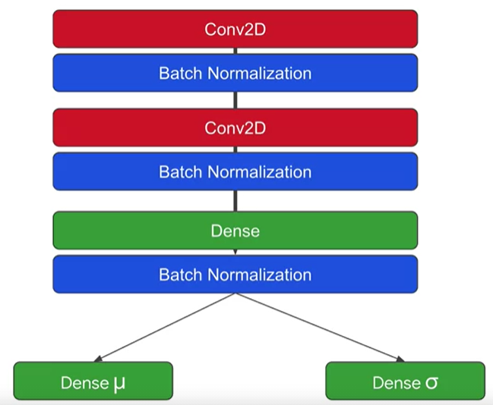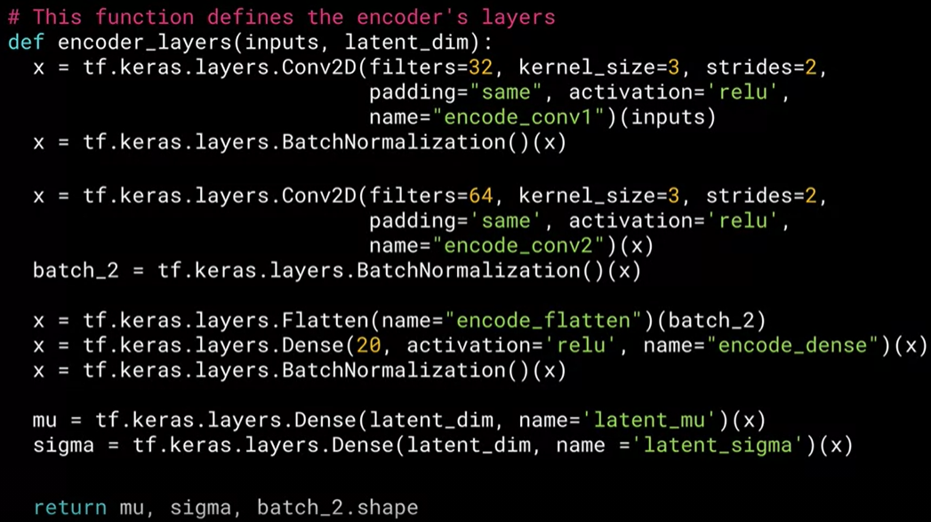

For the bottleneck part, we create a custom layer:

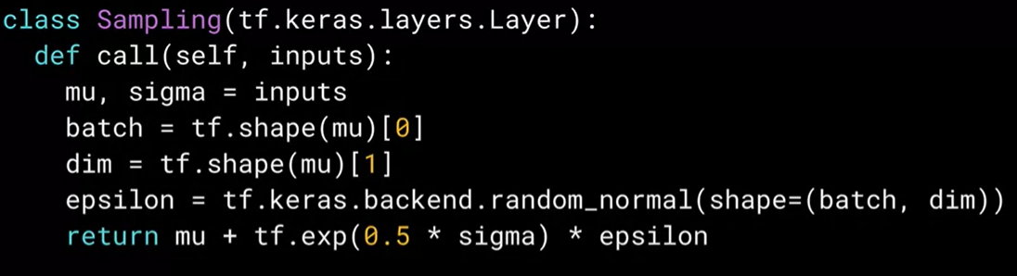

So, enconder + bottleneck is:

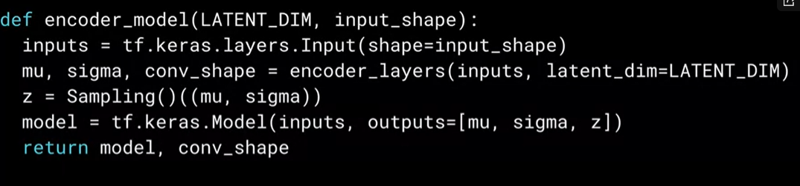

For the decoder, we have:

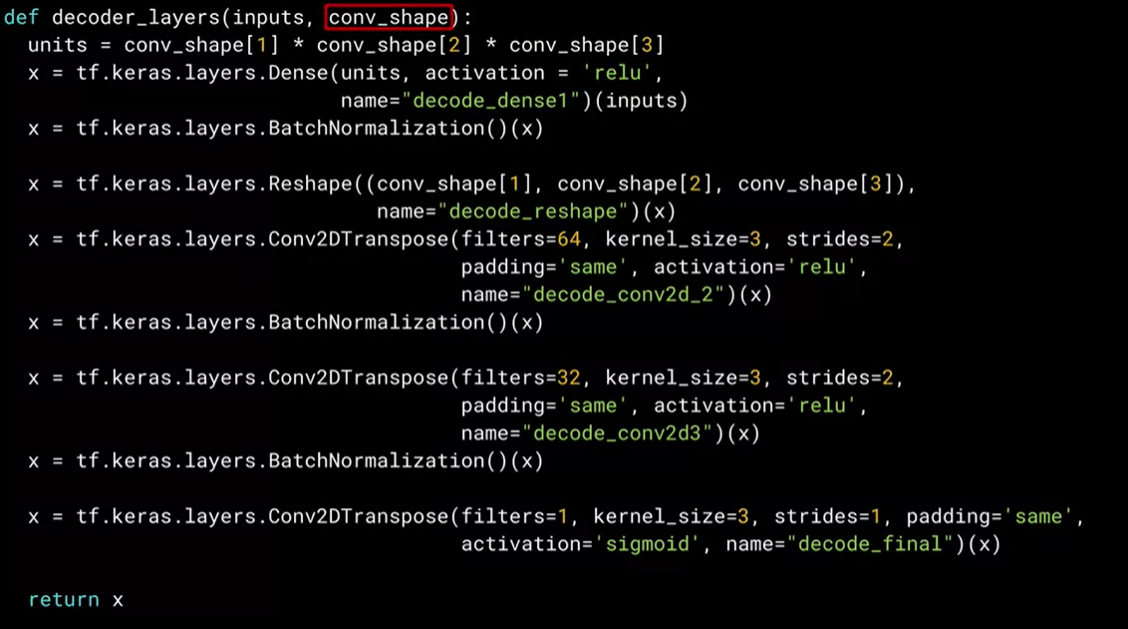

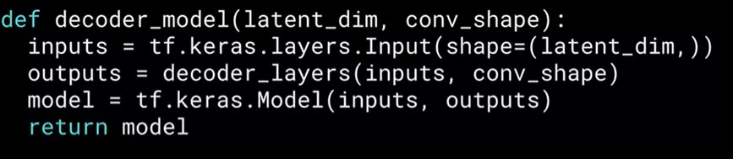

The loss function for the VAE is a little bit different. We use a Kullback-Leibler loss function:

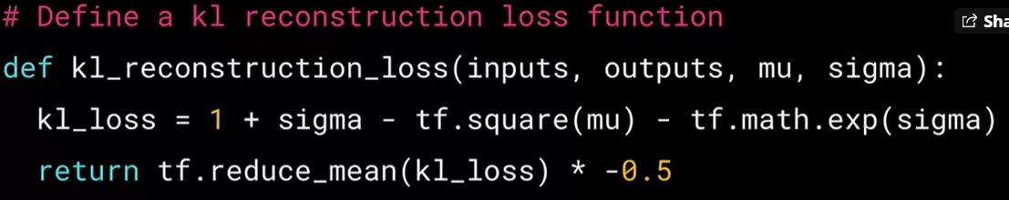

All together, the VAE model is:

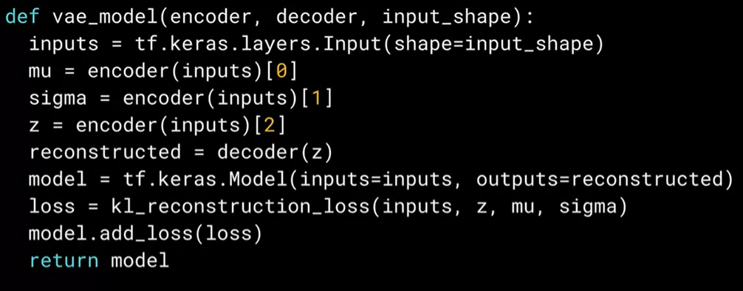

To train the VAE, we do:

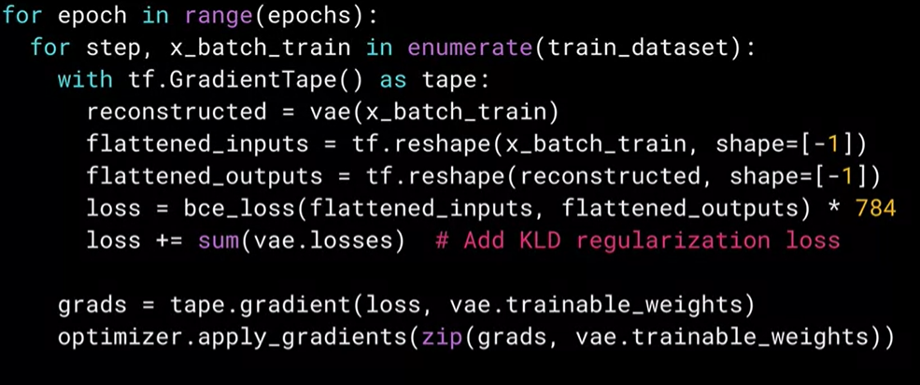

## Week 4: Generative Deep Learning with TensorFlow

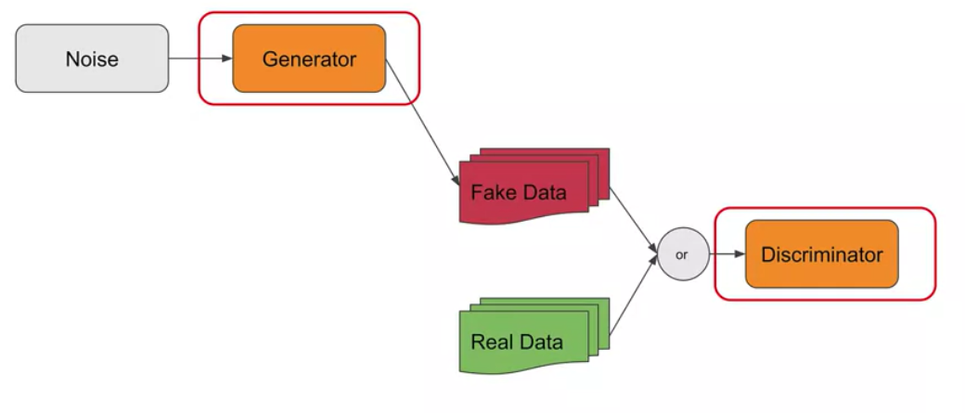

In GANs, we have random noise fed into a NN called the generator. This generator creates fake data. This data is then combined with real data and fed into another NN called the discriminator. The discriminator’s job is to determine if the input data that is given is fake (created with the generator) or real.

The generator’s job is to create fake data that is real enough to fool the discriminator, while the discriminator job is to learn to effectively identify real from fake data.

The generator never sees real images. It only sees noise. It learns from gradients that flow back from the discriminator. At the end, it is some sort of war between generator and discriminator. Making one better will force another to be better, and so on.

Since there are 2 NN in the architecture, training will also take 2 phases:

1. In the first phase we train the discriminator. It is given batches of labelled images which are labeled fake or real. This is a binary classification. In this phase, only the parameters within the discriminator are updated.
2. In the second phase we train the generator by trying to make it create fake images that trick the discriminator into believing that they are real. The parameters of the discriminator are frozen in this phase, but the results of its judgements whether the data is fake or real will be passed back to the generator, so it can optimize to produce more convincing fake data.

To build the generator, we can do the following:

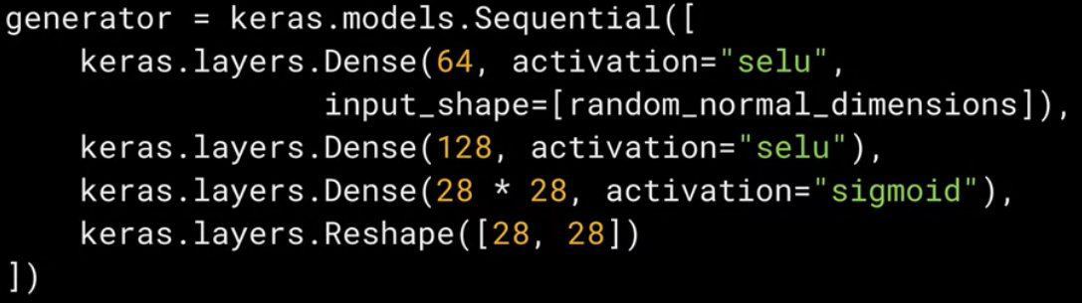

To build the discriminator network, we can do the following:

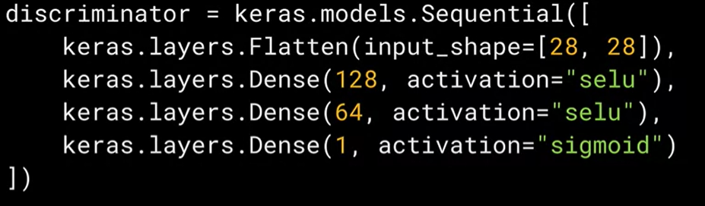

Note that the activation function is SELU and not ReLU. That’s a key difference in these networks. ReLU is useful when removing noise when classifying data by preventing negative values from cancelling out positive ones. But here we don’t want to remove data, and the SELU activation function is very useful for that.

To build the network, we do:

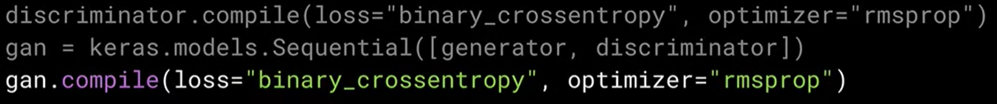

We first compile the discriminator. As it is a binary classifier (fake or real data), we use binary_crossentropy. Then we can create our GAN model with the generator as input and discriminator as output. Finally, the GAN is compiled with the same loss function and optimizer.

Training a GAN is a little bit different from normal NN, because there are 2 phases. This requires the building of a custom training loop:

1. Phase 1: train the discriminator  
   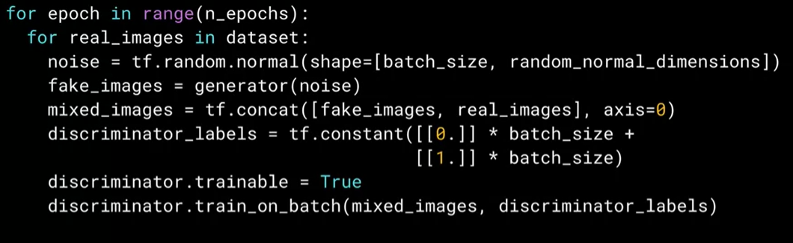

We first build random noise with the same size of the batch of real images and is in the custom dimension space (random_normal_dimensions is a hyperparameter that we can change). We then pass that random noise to the generator to get the first set of fake images. We then create a new set of data called mixed_images which is the concatenation of the generated fake images and real images that we pull from the dataset. The labels are set as 0 for the fake images and 1 for the real images. We set discriminator.trainable = True to say that we want to train the discriminator in this phase. And finally, we call the train_on_batch method on the discriminator to train it using the mixed images and the labels that we built.

1. Phase 2: train the generator  
   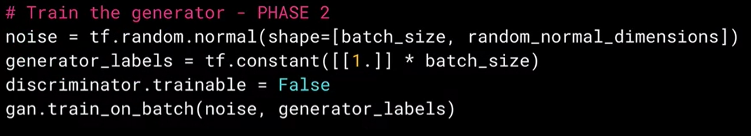

First, we generate noise as before. We want to fool the discriminator, so despite all those images being fake, we create the labels as all 1 indicating that we are claiming that those are real images and not fake. Then we freeze the discriminator by setting discriminator.trainable = False. Finally, we train the GAN using the noise and the generator labels to update the generator

What can happen is that the generator can start generating some specific type of data and ignore other types. For example, if we want to generate images of digits, the generator might optimize itself to specialize in generating 1 instead of the other digits, so all the generated numbers will be 1. This is called mode collapse. Fixing this is a huge area of research in GANs. We will see some architectures that approach this problem

Deep GANs

For example, Deep Convolutional GANs.

The generator of a Deep Convolutiona GAN can look like this:

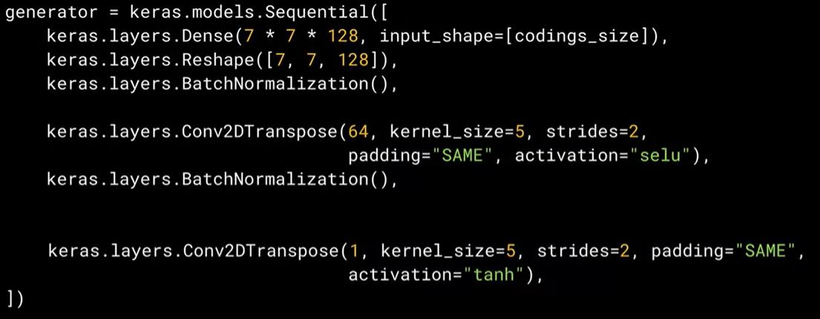

Some best practices are that we must use Conv2DTranspose instead of Conv2D, that we must use Batch Normalization in the generator except for the output layer, all activation functions must be SELU except for the output layer which must be tanh.

For the discriminator,

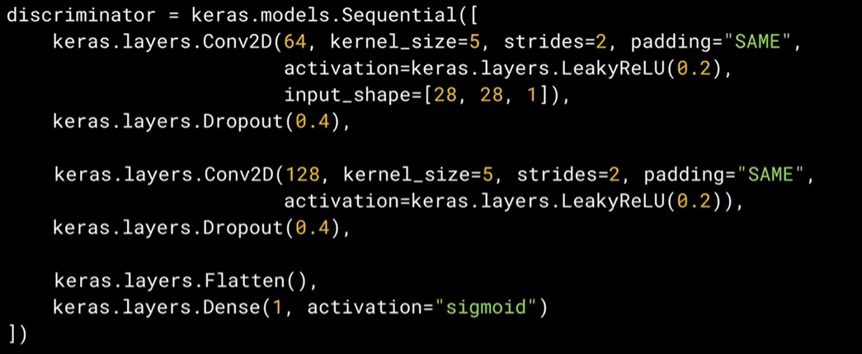

For the discriminator we can classify the images using CNN as usual, but some best practices are: instead of pooling after a convolutional layer, the use of strides can be used to reduce the dimension; Leaky ReLU can be used as activation in the discriminator.

Another good practice is to avoid the use of dense layers in the discriminator and generator.